

**Investigation into rhythmic gene expression in the entomopathogens   
*Ophiocordyceps camponoti-floridani* and *Beauveria bassiana***

A behavior manipulating specialist vs fast killing generalist

**Investigation into rhythmic gene expression in the entomopathogens   
*Ophiocordyceps camponoti-floridani* and *Beauveria bassiana***

A behavior manipulating specialist vs fast killing generalist

Minor research project

as part of the MLCS master & the bioinformatics profile

Minor research project

as part of the MLCS master & the bioinformatics profile

19 December 2021

19 December 2021

Utrecht university – University of Central Florida

Examiner: **Dr.** **Luis Lugones (UU)**

Host supervisor: **Dr. Charissa de Bekker (UCF)**

Utrecht university – University of Central Florida

Examiner: **Dr.** **Luis Lugones (UU)**

Host supervisor: **Dr. Charissa de Bekker (UCF)**

**By Roos Brouns**

**By Roos Brouns**

**Abstract** – Circadian clocks are hypothesized to be involved in various parasite-host interactions that involve adaptive manipulation of host behavior. The parasitic manipulation of host-clocks (PMHC) hypothesis posits that behavior manipulating parasites most likely break into the internal timekeeping machinery of the infected host to induce timely manipulations in host behavior necessary for the parasite’s growth and transmission. For instance, we observe a loss of rhythmicity in Carpenter ants infected with *Ophiocordyceps camponoti-floridani* and the typical manipulated biting behavior, 'the death-grip, happens at a synchronized timing of the day. To investigate the role of the fungal parasite clock during infection of the carpenter ants, we performed time-course RNA sequencing for 24 hours with a 2-hour sampling resolution of a manipulating fungus *O. camponoti-floridani* and non-manipulating fungus *Beauveria bassiana* grown as blastospores. We aimed to characterize and compare the endogenous clock components and identified genes with significant oscillating expression patterns in both entomopathogens. Here, we found differences between expression patterns of clock (-controlled) genes in the fungal species, revealing the functional complexity within fungal clocks. For both species we find putative secreted and transmembrane proteins to be enriched within groups of co-expressed genes generated by network analysis, which might play a central role during infection. However, we also find differences in processes that might be regulated by these 24h rhythms and their peak expression. We question if this might be related to the differences in the infection strategy of both fungi, as *O. camponoti-floridani* resembles more a hemibiotrophic lifestyle, while *B. bassiana* resembles more a necrotrophic lifestyle.

**Layman’s summary** – Many fungal pathogens can change the behavior of their insect host. One most commonly known example is the zombie ant. At first, upon infection, everything seems normal and the ant will participate in the social structure of the colony. However, inside the body of the ant, the fungus can start to grow, while staying unnoticed. After several days, the ants start to behave differently; they become asocial and start to wander more. Slowly, the fungus will take over the complete behavior of the ant, ultimately making it walk up a higher point where the ant will cling and bite to secure a locked position. Shortly after to so-called 'death-grip', the ant will die and the next thing seems straight out of a science fiction movie because the fungus emerges from the head. This death-grip is crucial for the life cycle of the fungus because the fungus needs it to reproduce and release new spores. How is this possible you wonder? We believe that the fungus can hijack the internal clock of the ant and reset it for its own schedule. This study helps to figure out how fungal clocks might be involved during the infection of their insect host and if it could be involved in causing the zombie ants.

**Abstract** – Circadian clocks are hypothesized to be involved in various parasite-host interactions that involve adaptive manipulation of host behavior. The parasitic manipulation of host-clocks (PMHC) hypothesis posits that behavior manipulating parasites most likely break into the internal timekeeping machinery of the infected host to induce timely manipulations in host behavior necessary for the parasite’s growth and transmission. For instance, we observe a loss of rhythmicity in Carpenter ants infected with *Ophiocordyceps camponoti-floridani* and the typical manipulated biting behavior, 'the death-grip, happens at a synchronized timing of the day. To investigate the role of the fungal parasite clock during infection of the carpenter ants, we performed time-course RNA sequencing for 24 hours with a 2-hour sampling resolution of a manipulating fungus *O. camponoti-floridani* and non-manipulating fungus *Beauveria bassiana* grown as blastospores. We aimed to characterize and compare the endogenous clock components and identified genes with significant oscillating expression patterns in both entomopathogens. Here, we found differences between expression patterns of clock (-controlled) genes in the fungal species, revealing the functional complexity within fungal clocks. For both species we find putative secreted and transmembrane proteins to be enriched within groups of co-expressed genes generated by network analysis, which might play a central role during infection. However, we also find differences in processes that might be regulated by these 24h rhythms and their peak expression. We question if this might be related to the differences in the infection strategy of both fungi, as *O. camponoti-floridani* resembles more a hemibiotrophic lifestyle, while *B. bassiana* resembles more a necrotrophic lifestyle.

**Layman’s summary** – Many fungal pathogens can change the behavior of their insect host. One most commonly known example is the zombie ant. At first, upon infection, everything seems normal and the ant will participate in the social structure of the colony. However, inside the body of the ant, the fungus can start to grow, while staying unnoticed. After several days, the ants start to behave differently; they become asocial and start to wander more. Slowly, the fungus will take over the complete behavior of the ant, ultimately making it walk up a higher point where the ant will cling and bite to secure a locked position. Shortly after to so-called 'death-grip', the ant will die and the next thing seems straight out of a science fiction movie because the fungus emerges from the head. This death-grip is crucial for the life cycle of the fungus because the fungus needs it to reproduce and release new spores. How is this possible you wonder? We believe that the fungus can hijack the internal clock of the ant and reset it for its own schedule. This study helps to figure out how fungal clocks might be involved during the infection of their insect host and if it could be involved in causing the zombie ants.

Table of Contents

1. Introduction 4

2. Results & Discussion 7

**2.1 Clock (-controlled) genes in *O. camponoti-floridani* and *B. bassiana*** 7

2.1.1 Clock components

2.1.2 Photoreceptors

2.1.3 Conculsion

**2.2. Non-expressed genes in *O. camponoti-floridani* and *B. bassiana*** 12

2.2 Conclusion 13

**2.3 Rhythmicity analysis** 13

2.3.1 *O. camponoti-floridani*

2.3.2 *B. bassiana*

2.3.3 Comparing 24 rhytmic genes

2.3.4 Conclusion

**2.4 Co-expressed modules of genes in *O. camponoti-floridani* and *B. bassiana*** 20

2.4.1 *O. camponoti-floridani*

2.4.2 *B. bassiana*

2.4.3 Conclusion

**2.5 Differentially expressed genes during manipulation and their rhythmicity** 25

2.5.1 *O. camponoti-floridani*

2.5.2 *B. bassiana*

2.5.3 Conclusion

Conclusion & Future avenues 27

Materials & Methods 28

Obtaining fungal samples and RNA-Sequencing

Obtaining normalized gene expression

Rhythmicity analysis

Clustering of co-expressed genes

Functional annotations

Enrichment analysis

Homologous genes

Supplementary info 30

References 30

Table of Contents

1. Introduction 4

2. Results & Discussion 7

**2.1 Clock (-controlled) genes in *O. camponoti-floridani* and *B. bassiana*** 7

**2.2. Non-expressed genes in *O. camponoti-floridani* and *B. bassiana*** 12

2.2 Conclusion 13

**2.3 Rhythmicity analysis** 13

*2.3.3 Comparing 24h rhythmic genes of O. camponoti-floridani and B. bassiana* 18

**2.4 Co-expressed modules of genes in *O. camponoti-floridani* and *B. bassiana*** 20

**2.5 Differentially expressed genes during manipulation and their rhythmicity** 25

Conclusion & Future avenues ------- 28

Supplementary info ------------------- 29

References ------------------------------ 29

Table of Contents

1. Introduction 4

2. Results & Discussion 7

**2.1 Clock (-controlled) genes in *O. camponoti-floridani* and *B. bassiana*** 7

**2.2. Non-expressed genes in *O. camponoti-floridani* and *B. bassiana*** 12

2.2 Conclusion 13

**2.3 Rhythmicity analysis** 13

*2.3.3 Comparing 24h rhythmic genes of O. camponoti-floridani and B. bassiana* 18

**2.4 Co-expressed modules of genes in *O. camponoti-floridani* and *B. bassiana*** 20

**2.5 Differentially expressed genes during manipulation and their rhythmicity** 25

Conclusion & Future avenues ------- 28

Supplementary info ------------------- 29

References ------------------------------ 29

# 1. Introduction -------------------------

Many fungal parasites have evolved the ability to manipulate host behavior to increase their reproductive success (Moore 2002). For instance, *Entomophthora muscae* is a fungal entomopathogen that infects flies belonging to several dipreran families which induces manipulating behavior that positively affects wind-mediated spore dispersal and spore production (Gryganskyi et al. 2017; MacLeod et al., 1985). Other examples of behavior-manipulating fungi are *Eryniopsis lampyridarum* which infects the goldenrod soldier beetle (*Chauliognathus pensylvanicus*) and *Massospora cicadina* which infects cicadas (Watson et al. 1993; Cooley et al. 2018). Species belonging to the genus *Ophiocordyceps* are well known for their ability to infect and manipulate ants to induce “zombie-like” behaviors (de Bekker 2019, Merrow, and Hughes 2014) Manipulated ants infected by an *Ophiocordyceps* spore both bite onto and cling to plant substrates just before death, a behavior called the ‘death grip’. Usually, the time of death is within 6 hours after the ant is attached. Once the host has died, the fungus consumes the host and forms the fruiting body, which eventually sporulates to complete the life cycle (Hughes et al. 2011). The death-grip provides a stable growth and transmission site necessary for the dispersal of spores from a higher vantage point that appears to be adaptive for the fungal parasite (Hughes et al., 2011; de Bekker et al., 2015; Will et al., 2020).

Along with the highly tractable signs of manipulation, i.e. the death-grip, more subtle changes in behavior have been reported days prior to biting. For instance, infected ants of the species *Camponotus leonardi* become day-active upon infection, while healthy ants are typically active during the night (Hughes et al. 2011). Moreover, disrupted foraging behavior has been demonstrated in *Camponotus floridanus* ants during infection with *Ophiocordyceps camponoti-floridani.* Starting from 10-15 days post-infection, infected ants are more likely to be found off-trail than healthy ants and display aimless locomotion in a laboratory setup (Trinh, Oulette, and de Bekker 2020). Additionally, social changes in the foraging strategy were observed. Normally, the *C. floridanus* foraging ants in a colony will work together as a group, communicating and dividing labor during their foraging runs (Trinh, Oulette, and de Bekker 2020). This foraging strategy is observed in other *Camponotus* species as well (Traniello 1977; Ashwathi, Puspita, and Ganeshaiah 2020). After infection, however, *O. camponoti-flordani* infected ants no longer participate in these group structures (Trinh, Oulette, and de Bekker 2020). One other social behavioral change in infected *Camponotus* species includes loss of aggression, while non-infected ants are known to be extremely aggressive towards ants of other species or even from another colony (Hughes et al. 2011).

The mechanisms underlying the ability of *Ophiocordyceps* spp. to manipulate behavior likely involve the secretion of several secondary metabolites and small proteins (de Bekker, Beckerson, and Elya 2021). There are many avenues for fungal effector proteins, e.g., enterotoxins, to affect the host. One potential impact of secreted effectors may be the interference with host translation, thereby altering different aspects of the hosts’ biology at the molecular level (Zhang et al. 2021). Differential expression and homology identified through transcriptomic and genomic analyses have suggested that enterotoxins play a major role in the pathogenicity of *Ophiocordyceps* during infection of their respective hosts (De Bekker, Ohm, et al. 2017; Will et al. 2020). During manipulation, the expression of gene modules enriched for extracellular and secretion signals in the fungus were found to correlate with the expression of ant gene modules associated with neuronal function. Dysregulation of these host neuronal activities, including neurotransmitter and neuron-modulating compounds, are a plausible parasite strategy to manipulate host behavior (Will et al. 2020).

Light is shown to play an important role in regulatory mechanisms of host manipulating behavior (Andriolli et al. 2019). A field study in Brazil investigated the importance of light intensity on the position of death and fruiting body formation in *Ophiocordyceps* infected carpenter ants by experimentally manipulating the incident of illumination in their test fields. *Camponotus atriceps* ants infected with *Ophiocordyceps camponoti-atricipis* displayed strong positive phototactic behavior, as they continued searching for light in shaded areas moments before the final ‘death grip’ behavior was observed. It, therefore, stands to reason that *Ophiocordyceps* is able to turn their hosts into ‘light-seekers’. Changing the ant into light seekers offers several benefits to the fungus’s reproductive success because the number of infected ants and developed fruiting bodies were found to be significantly higher in lighter areas (Andriolli et al. 2019).

Light is a well-known stimulus for several of the feedback loops in transcription and translation that give rise to oscillating rhythms, most notably as circadian rhythms (Tosini and Menaker 1996). These biological ‘clocks’ are endogenous mechanisms that control daily rhythms in physiology, biochemical pathways or behavior, and are regulated by clock control genes that respond to zeitgebers, e.g., light, temperature, metabolism, and social cues (Dunlap, Loros, and DeCoursey 2004). These mechanisms are heavily conserved across all kingdoms of life. The biological clocks of *Drosophila melanogaster* for example very closely resemble the clocks of *Neurospora crassa,* working via negative feedback loops regulated by phosphorylation (Rosato, Tauber, and Kyriacou 2006).

These clock-controlled genes downstream in the feedback loop have been studied extensively in the fungus *N. crassa* (Figure 1) (Heintzen and Liu 2007; Dunlap and Loros 2006; K., C., and J. 1997; Montenegro-Montero, Canessa, and Larrondo 2015). The transcriptional/translational negative feedback loop (TTFL), in *N. crassa*, consists of the White Collar Complex (WCC), which is a heterodimeric transcriptional complex formed by the White Collar 1 (WC-1) and White Collar 2 (WC-2) transcription factors. The WCC complex induces *frq* expression, which results in the protein FRQ, which associates with an FRQ-interacting RNA helicase (FRH) (Cheng et al. 2005). This protein complex, termed FFC, recruits CK1, enters the nucleus and phosphorylates WC1 which makes it inactive again (Baker, Loros, and Dunlap 2012). These interactions in the nucleus are critical for the timekeeping of the feedback loop where FRQ functions as a key oscillator of the clock. This circadian oscillator functions in constant darkness in the absence of any signals from the external environment (Schwerdtfeger and Linden, 2000).

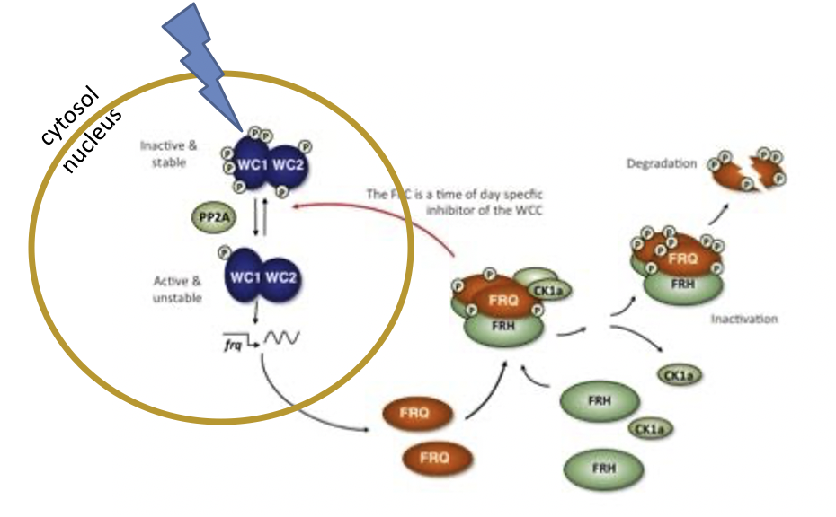

**Figure 1: The transcriptional/translational negative feedback loop (TTFL) in N. crassa**. The clock in N. crassa consists of White Collar 1 (WC-1) and White Collar 2 (WC-2), which forms a heterodimeric transcriptional complex, White Collar Complex (WCC). The WCC complex induces the expression of frq expression, which translates into the protein FRQ. FRQ associates with an FRQ-interacting RNA helicase (FRH) (Cheng et al. 2005) and subsequently recruits CK1, to enter the nucleus and inactivates WC1 by phosphorylation (adapted from Upadhyay, et al. 2019).

Clock-controlled genes such as *frq, wc-1,* and *wc-2,* were widely identified in other fungi as well. For instance, WC-1, which is also a blue light receptor that can reset the clock, is highly conserved across Pezizomycetes, Basidiomycetes, Zygomycetes, and even some Hemiascomycetes (Dunlap and Loros 2006). More recently, the endogenous clock of *Ophiocordyceps kimflemingiae* was demonstrated along with key oscillators FRQ, WC-1, and WC-2 (De Bekker, Will, et al. 2017).

However, while many of these clock genes are conserved across the fungal kingdom, there are differences between fungi as well. *Aspergillus* for example harbors no *frq* homologs in the genome (Salichos and Rokas 2010). The clock of *Beauveria bassiana*, a general insect pathogen in the family *Cordyceps*, also differs from the TTFL of *N. crassa*. Instead of one *frq* gene, *B. bassiana* harbors two distinct FRQ homologs, Frq1 and Frq2, which are both important for non-rhythmic conidiation and thus virulence in *B. bassiana* (Tong et al. 2021). In addition, Frh is required for the stability of Frq1 and Frq2 in *B. bassiana* and is involved in transcriptional activation of *wc-1* and *wc-2*, along with other the blue-light receptors *vivid* (*vvd*) and far-red light receptor *phytochrome* (*phy)* (Tong et al. 2020)*.*

Circadian rhythms also appear to be involved in the infection process of *Ophiocordyceps*. For instance, field studies in Thailand have shown that the death grip induced in *O. unilateralis s.l.*-infected *C. leonardiants* ants occurs around solar-noon (Hughes et al. 2011). The role of circadian rhythms in this process is also corroborated by laboratory studies with *Ophiocordyceps kimflemingiae* and *O. camponoti-floridani* where biting behavior was also demonstrated to be synchronized to specific times in the day, albeit during the ‘early morning’ stage of the incubation cycle (de Bekker et al. 2015; Will et al. 2020). Furthermore, infected ants only display manipulated biting behavior in the lab when exposed to 24-h light and temperature cycles, thus illustrating a clear role for circadian rhythms during infection (de Bekker et al. 2014). Together, these studies indicate that phase shift from the pathogenic yeast-like phase of growth to the saprophytic mycelium-like phase required for the production of the fruiting body is likely dependent on very specific environmental conditions, conditions that are introduced differently in a laboratory set-up (de Bekker et al. 2021; de Bekker et al. 2019)

Interestingly, the host’s circadian rhythm is also affected during infection by *Ophiocordyceps* species. For example, *C. floridani* ants start to lose their rhythmicity shortly after *Ophiocordyceps* infection. Healthy ants are nocturnal and typically do not leave the nest during the daytime; however, ants infected with *Ophiocordyceps* become increasingly active during the day, eventually losing their natural nocturnal rhythmicity entirely in later stages of infection (Trinh, Oulette, and de Bekker 2020).

However, despite the wealth of preliminary data linking these genotypes to behaviorally

modified phenotypes, the role of rhythmic genes in this process remain largely unexplored.

The aforementioned experimental evidence indicating that biological clocks are involved in the manipulation of carpenter ant behavior by *Ophiocordyceps* has led to the hypothesis that parasitic manipulation of host-clocks (PMHC) plays a central role in *Ophiocordyceps* pathogenicity and leads to the many behavioral changes observed during infection.

PMHC hypothesis posits that behavior manipulating parasites, such as those of from *Ophiocordyceps* species complex, most likely break into the internal timekeeping machinery of the infected host to induce timely manipulations in host behavior necessary for the parasite’s growth and transmission (de Bekker, Beckerson, and Elya 2021).

For the PHMC hypothesis to hold, it stands to reason that a certain degree of plasticity of the endogenous clock of the ant is required. Plasticity in circadian clock neurons that give rise to photoperiod-linked behaviors was demonstrated in insects, such as *Protophormia terraenovae* and *Leucophaea maderae* (Shiga 2013). More recently, the plasticity of the ant clock was demonstrated in *C. floridanus*, in which the internal rhythmicity is shown to be based upon their social role in the colony and likely gives rise to the stereotypical, daily behaviors that are involved with that role (Das et al, 2021). Work by Das, et al. (2021) demonstrated that the circadian clocks were light entrainablein *Camponotus* ants, plus inherently plastic. This can be observed in the phase, amplitude, and period length with which circadian processes oscillate as ants develop and adapt to changes in their social environment. These changes result in behaviors dependent on the time of day known as ‘chronotypes’ (Das et al. 2021). This is consistent with previous comparative transcriptomics work that revealed differential expression of clock-controlled genes in *C. floridanus* ants during manipulation by *O. camponoti-floridani*, including downregulation of the core clock gene *clock*, which has a similar function to the *frq* in *N. crassa* (Will et al. 2020). Together, these results suggest that indeed *Ophiocordyceps* host clocks are plastic, providing the foundation for a possible strategy of *Ophiocordyceps* to hi-jack the clock during manipulation.

As it stands, the importance of circadian rhythms and clock-controlled genes during fungal infection remains poorly understood. Changes in rhythmicity and differentially expressed clock genes of the ant could either be a specific strategy of manipulating parasites or a general hallmark of infection by parasites. Ants infected *with B. bassiana*, a more generalist, non-behavioral manipulating fungus, also show slightly different foraging behaviors, behaviors that might be categorized as “sickness behavior”. It is therefore important to tease apart behaviors are that are common illness responses from those caused directly by the parasite. Work by Trinh, Oulette, and de Bekker demonstrated that when challenged in a foraging maze setup, *B. bassiana*-infected *C. floridanus* ants retain their rhythmicity throughout infection, unlike those infected with *O. camponoti-floridani*, providing evidence that disruption of clock genes is a result of host manipulation and not a general response to illness (2020). This suggests that the loss of rhythmicity might be a specific feature of host manipulating parasites. However, further comparisons of manipulating and non-manipulating parasites are necessary to test this hypothesis.

To investigate the role of the fungal parasite clock during infection of the carpenter ants, we wished to characterize and compare the endogenous clock of a manipulating fungus *O. camponoti-floridani* and non-manipulating fungus *B. bassiana*. To investigate rhythmicity and cycling transcript in *O. camponoti-floridani* and *B. bassiana*, RNA seq was performed over 24 hours, with a sampling resolution of 2 hours. Both species were grown as blastospores in liquid culture, to resemble the form of the fungi when they are inside the host, thus during infection (Wang and Wang 2017). In our study, we hypothesized that both fungi would have similar rhythmic signals as both fungi have a light entertainable endogenous clock that is involved in several processes. While we expect that the clocks would be similar, we were also interested in the differences in rhythmically expressed genes that we might find between the two fungi, and the contributions they possibly have during infection, and during manipulation of host behavior in the case of *O. camponoti-floridani*. To test our hypothesis, we first identified rhythmic genes that have an oscillating gene-expression profile over a 24h, 12h, or 8h period in both *O. camponoti-floridani* and *B. bassiana*. We searched the genome of both fungi for homologs of clock (-controlled) genes identified in *N. crassa* and compared their single gene expression patterns with what is found in other fungi. Next, we analyzed the expression values of the genes identified as rhythmic by determining their peak expression activity and subsequentially performed enrichment analysis to gain insight into the functions and processes in which these genes might be involved. To better understand the endogenous clock and rhythmic gene expression as groups of genes that influence each other, we performed network analysis based on the co-expression of the genes. We searched for modules (clusters of genes) that we consider rhythmic and analyzed their peak activity of expression (e.g. night- or day peaking) along with enrichment analysis results to get more insight into the function of the clusters. Finally, we try to link previously found differentially expressed genes of *O. camponoti-floridani* during manipulation, along with the identified clock (-controlled), to rhythmically co-expressed modules, aiming to find meaningful insights into clock-controlled genes and their role in creating manipulating behaviors.

# 2. Results & Discussion ---------------

## **2.1 Clock (-controlled) genes in *O. camponoti-floridani* and *B. bassiana***

2.1.1 Clock components

To identify components of the endogenous clock in *O. camponoti-floridani* and *B. bassiana* we searched both genomes for homologs of the clock(-controlled) genes in *N. crassa* and analyzed their expression pattern during the 12:12h L:D cycle. Since homologs of *frq, wc-1,* and *wc-2* are found across various fungal species, like *Pyronema confluens* (Pezizomycetes), *Magnaporthe oryzae* (ordariomycetes), and *Trichoderma spp.* (Sordariomycetes), we expect them to find in *O. camponoti-floridani* and *B. bassiana* as well (Larrondo and Canessa 2018). We identified a homolog of *frq* in *O. camponoti-floridani* (GQ602_006690) along with *frq1* (BBA_01528) and *frq2* (BBA_08957) in *B. bassiana* (Table1)*.* Previous research into the endogenous clock of *O. kimflemingiae* identified homologs of *frq, wc-1,* and *wc-2,* which homologs were also present in *O. camponoti-floridani* and *B. bassiana* (de Bekker et al. 2017) (Table1).Oscillating transcripts levels of *frq, wc-1,* were demonstrated for *N. crassa* and *O. kimflemingiae* (Heintzen, Loros, and Dunlap 2001; Hurley et al., 2014; de Bekker et al. 2017). Additionally, oscillations of *frq* transcript levels were also present in *M. oryzae* under a 12:12 LD cycle (Salichos and Rokas 2010). We, therefore, expect to find rhythmic expression patterns for *frq* and *wc-1* in *O. camponoti-floridani* and *B. bassiana* as well.

As we hypothesized, we found significantly 24h oscillating transcripts for *frq,* and *wc-1* in *O. camponoti-floridani* (Figure 2)*.* We observed an antagonistic expression pattern between *frq* having peak activity during the subjective day phase and *wc-1* having a peak activity during the subjective night phase, which corresponds to the light-induced inhibiting role of FRQ on WC-1 in *N. crassa* (Montenegro-Montero, Canessa, and Larrondo 2015) (Figure 2A&B).

|  |  |  |  |  |  |  |  |  |  |
| --- | --- | --- | --- | --- | --- | --- | --- | --- | --- |
| *O. camponoti-floridani* | | | *B. bassiana* | |  | | *O. kimflemingiae* | | *N. crassa* |
| Gene ID | **24h rhythmic** | **GammaP** | **homolog** | **24h**  **rhythmic** | | **GammaP** | **homolog** | **24**  **rhythmic** | **ortholog** |
| GQ602_006690 | yes | 0.05 | BBA_01528 (frq1) | no | | 0.08 | Ophio5|6064 | yes (DD) | frq |
| - | - | - | BBA_08957 (frq2) | - | | - | - | - | - |
| GQ602_001775 | yes | 0.02 | BBA_10271 | no | | 0.12 | Ophio5|4975 | yes (LD) | wc-1 |
| GQ602_002346 | yes | 0.01 | BBA_01403 | yes | | 0.01 | Ophio5|889 | No | wc-2 |
| GQ602_001187 | yes | 0 | BBA_02876 | yes | | 0.04 | Ophio5|6595 | yes (LD) | vvd |
| GQ602_001137 | yes | 0.01 | BBA_02816 | no | | 0.51 | Ophio5|4324 | yes (DD) | phy-1 |
| GQ602_006230 | yes | 0.002 | BBA_02424 | yes | | 0.001 | Ophio5|2114 | Yes (LD) | cry-dash |

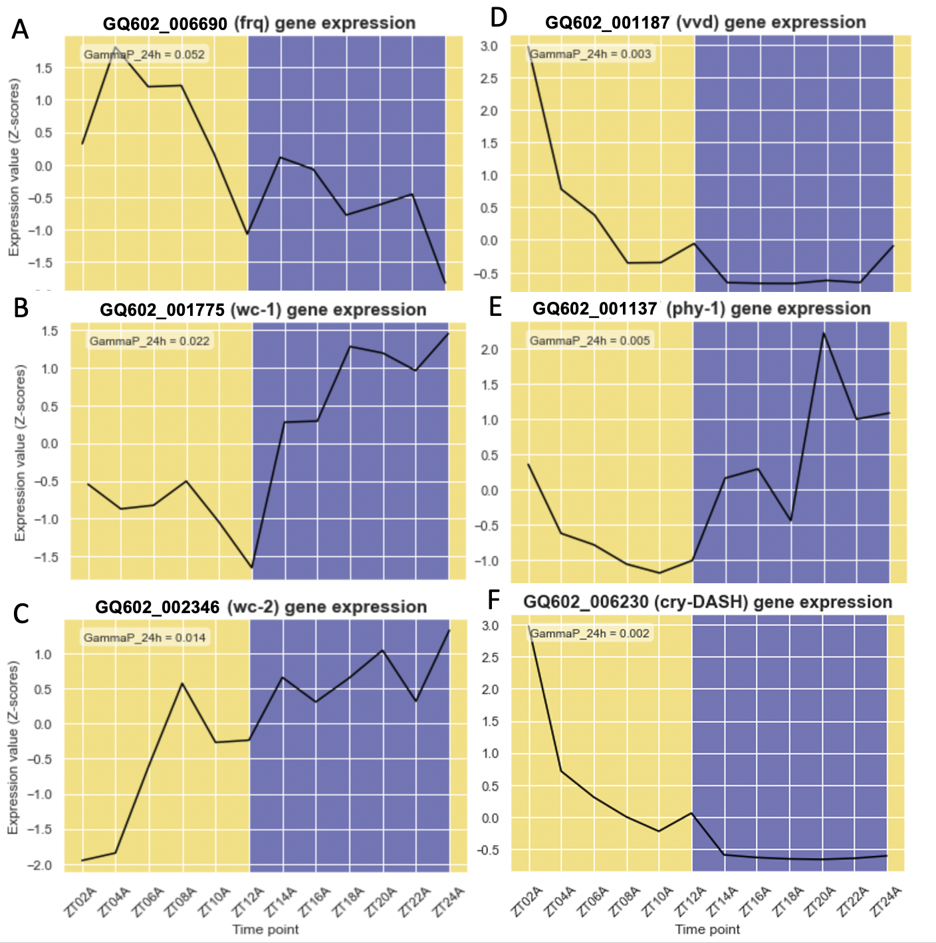

**Table 1: Identification of candidate clock (-controlled) genes in O. camponoti-floridani and B. bassiana.** Results for each gene if the transcript is considered 24h rhythmic along with the GammaP values are given. For each gene, the homologs in O. kimflemingiae and N. crassa are given as well.

**Table 1: Identification of candidate clock (-controlled) genes in O. camponoti-floridani and B. bassiana.** Results for each gene if the transcript is considered 24h rhythmic along with the GammaP values are given. For each gene, the homologs in O. kimflemingiae and N. crassa are given as well.

**Figure 2:** **Gene expression patterns clock (-controlled) genes in O. camponoti-floridani**. Normalized expression patterns are shown of homologs of A) frq, B) white collar-1, C) white collar-2, D) vivid, E) phytochrome-1, F) crypotochrome-dash over 24 hours in a light:dark cycle of 12:12 hours obtained by RNA-seq sampling every 2 hours. The x-axis represents the time points and the y-axis represents the expression values in Z-score. For each gene, the GammaP value of the statistical 24h rhythmicity analysis is given.

**Figure 2:** **Gene expression patterns clock (-controlled) genes in O. camponoti-floridani**. Normalized expression patterns are shown of homologs of A) frq, B) white collar-1, C) white collar-2, D) vivid, E) phytochrome-1, F) crypotochrome-dash over 24 hours in a light:dark cycle of 12:12 hours obtained by RNA-seq sampling every 2 hours. The x-axis represents the time points and the y-axis represents the expression values in Z-score. For each gene, the GammaP value of the statistical 24h rhythmicity analysis is given.

In *B. bassiana,* the

two distinct *frq* genes *frq1* (BBA_01528) and *frq2* (BBA_08957) were not identified as 24h rhythmic by our analysis. *Frq1* had a GammaP value of 0.082 and showed peak activity during the day while being downregulated right after the lights were turned off (Figure 3A). Although *frq1* is not significantly rhythmic, the expression seems to be regulated by light which is similar to *N. crassa* and our results in *O. camponoti-floridani* (Collett et al. 2002). The study of Tong et al (2021) showed stable protein levels of Frq-1 and Frq-2 in the cytosol, but opposite dynamics in the nucleus. It could be that the rhythmic dynamics of Frq1 are post-translational regulated and therefore we could not have picked it up with RNA sequencing. Another explanation could be that the combined levels of mRNA to maintain a stable Frq1 level in de nucleus outshines the rhythmic expression level in the nucleus, and therefore we did not pick it up as statistically rhythmic in our analysis. In the study of Tong et al (2021), cytosolic levels were measured as a ratio with β-tubulin, while the ratio in the nucleus was measured with histone H3 probed by an anti-H3 antibody. Both are standard measures for cytosolic and nucleus protein level ratios, but it does not allow comparison between the different cell tissues.

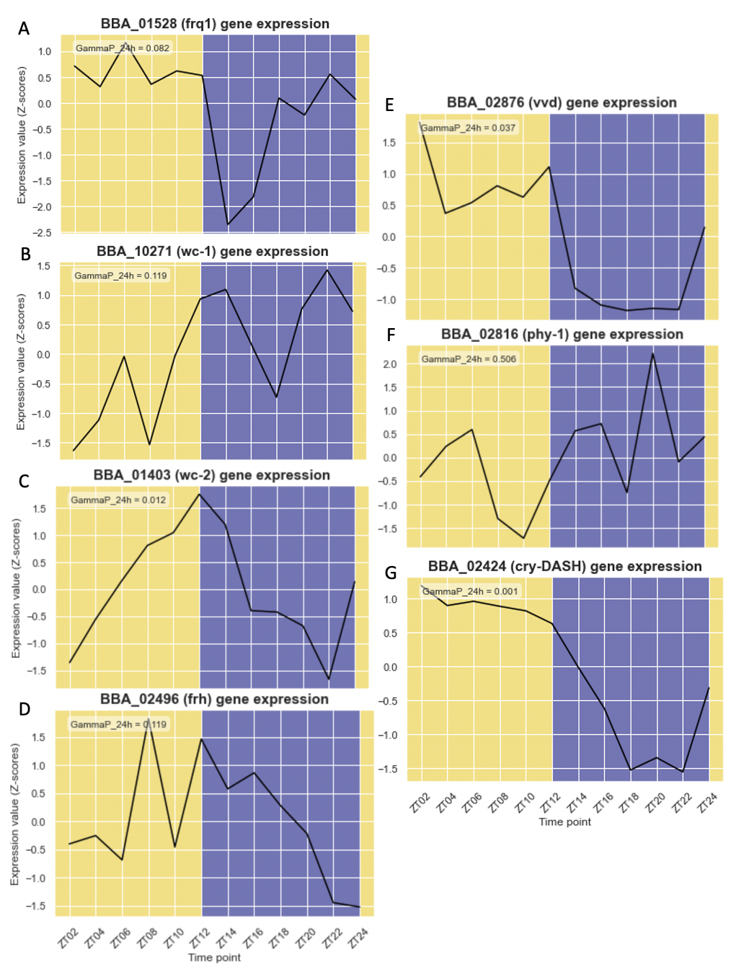We found *frq2* not to be expressed at all (FPKM = 0 at all time points, therefore plot is not shown in Figure 3), while Frq2 has been reported to be expressed when grown in hyphal culture and regulated by an *frh* homolog (BBA_02496) which is

**Figure 3: Gene expression patterns clock (-controlled) genes in B. bassiana**. Normalized expression patterns are shown of homologs of A) frequency-1, B) white collar-1, C) white collar-2, D) FRQ-interacting RNA helicase, E) vivid F) phytochome-1, G) cryptochrome-dash over 24 hours in a light:dark cycle of 12:12 hours obtained by RNA-seq sampling every 2 hours. The x-axis represents the timepoints and the y-axis represents the expression values in Z-score. For each gene, the GammaP value of the statistical 24h rhythmicity analysis is given.

f A) frequency-1, B) white collar-1, C) white collar-2, D) FRQ-interacting RNA helicase, E) vivid F) phytochome-1, G) cryptochrome-dash over 24 hours in a light:dark cycle of 12:12 hours obtained by RNA-seq sampling every 2 hours. The x-axis represents the timepoints and the y-axis represents the expression values in Z-score. For each gene, the GammaP value of the statistical 24h rhythmicity analysis is given.

part of the TTFL in *N. crassa* and involved in the activation of WC-1 and WC-2 in *B. bassiana* (Guo, Cheng, and Liu 2010; Tong et al. 2020)*.* However, we grew *B. bassiana* as blastospores to resemble the form of the parasitic fungus when is in the hemocoel of the host during infection. It is shown that *frq-2* is important for non-rhythmic conidia yield in *B. bassiana,* and thus for transmission to its host (Tong et al. 2021; 2020). It could be that some genes important for transmission expressed during hyphal growth are not expressed in the blastospore phase during infection. Furthermore, we also did not find a significantly rhythmic signal for *wc-1,* while we do find peak activity during the subjective night phase which is similar to *O. camponoti-floridani* (Figure 3B). These results together imply that the clock in *B. bassiana* might function differently than in *O. camponoti-floridani.* Since at present, there is little known about the clock of *B. bassiana,* especially during the blastospore phase and thus infection. Therefore, more time-course study’s of *B. bassiana’s* clock is necessary to understand what the similarities and differences are with other fungal clocks.

Since Frq1 and Frq2 were previously found to be regulated by an FRH homolog (BBA_02490) in *B. bassiana*, we were interested in the expression patterns of the *frh* homolog. We found *frh* not significantly 24h rhythmic and in *B. bassiana* (GammaP = 0.12) nor in *O. camponoti-floridani* (GQ602_ 003749) (GammaP = 0.17) (Figure 3C). In *N. crassa,* FRH is demonstrated to be an important component of the circadian clock but has not been shown to have an oscillating signal, which lines up with our findings (Guo, Cheng, and Liu 2010). Furthermore, we observed *wc-2* as 24h rhythmic in both *O. camponoti-floridani* and *B. bassiana,* with peak activity during the night and dusk phase, respectively(Figure 2B&3B). While studies have shown that WC-2 is always present in the nucleus in great excess of WC-1, and thus is not a limiting factor, this does not mean that the mRNA levels are also stable (Cheng et al. 2001; Denault et al. 2001).

2.1.2 Photoreceptors

Since light is an important zeitgeber, we wished to identify and analyze the expression of the photoreceptors that were previously identified as rhythmic in *O. kimflemingiae* and *N. crassa* (Table1). In *N. crassa,* the blue-light receptor VVD is important for adaptation to light, regulation of several blue-light-regulated genes, and light resetting of the circadian clock (Heintzen, Loros, and Dunlap 2001; Schwerdtfeger and Linden, 2003). We found *vvd* (GQ602_001187 and BBA_02876) to be significantly rhythmic and spiked during the subjective day phase in both *O. camponoti-floridani* and *B. bassiana* (Figure2D&3E). This suggests that VVD is induced by light. This is in line with previous findings in *O. kimflemingiae,* in which *vvd* transcripts were also found to be significantly rhythmic under the LD cycle and expressed in response to light (de Bekker et al. 2017). In *B. bassiana,* the intracellular translocation of VVD, along with transcriptional linkage to WC-1 and Phy-1, was demonstrated to act in a day-light dependent manner (S. M. Tong

et al. 2018). Furthermore, we find that levels of *vvd* mRNA start to rise before the lights are turned on, suggesting the involvement of circadian rhythms as well in the regulation of *vvd* (Figure 2D&3E, ZT22-ZT24)*.*  In *N. crassa, vvd* is under the control of the WCC, demonstrating the linkage with the circadian clock (Heintzen, Loros, and Dunlap 2001).

Other well-known light receptors are phytochromes, which sense (far-) red light (Rockwell, Su, and Lagarias 2006). Although phytochromes are primarily found in plants, *phy* homologs are also found in *Aspergillus nidulans, N. crassa, O. kimflemingiae,* and *B. bassiana,* (Blumenstein et al. 2005; de Bekker et al. 2017; Qiu et al. 2014; Froehlich et al. 2005). We found *phy-1* to be significantly 24h rhythmic in *O. camponoti-floridani* (GQ602_001137, GammaP = 0.01)*,* but not in *B. bassiana* (BBA_02816, GammaP = 0.5) (Table1). Interestingly, we found a peak activity of *phy-1* during the subjective night phase in both fungi, while we could expect peak activity during the day as it is a light receptor (Figure 2E&3F).In *A. nidulas,* the receptor for a complex similar to WCC of *N. crassa* and is important for asexual sporulation under red-light conditions, while in *B. bassiana* it controls conidiation in response to daylight (Blumenstein et al. 2005; Qiu et al. 2014). Since we grew *B. bassiana* in as blastospore, which is involved in a later step than conidiation during the infection cycle, we possibly see a non-rhythmic expression pattern. In *N. crassa,* however, *phy* transcripts are regulated by the circadian clock insteadof light, which might be the case for *O. camponoti-floridani* as well (Froehlich et al. 2005). To strengthen this, *phy-1* expression was rhythmic in *O. kimflemingiae* under constant-dark conditions, which shows that *phy-1* oscillating transcripts levels are clock regulated and not light regulated (de Bekker et al. 2017).

Lastly, we searched for homologs of the light photoreceptor CRYPTOCHROME (CRY). In *N.crassa* CRY is essential for an frq-less-oscillator (FLO) named CRY-dependent oscillator (CDO), which is an oscillator mechanism important for rhythmic spore development in the absence of the well-characterized FRQ/WCC oscillator (Nsa et al. 2015). In both *O. camponoti-floridani* and *B. bassiana,* we identified homologs of *cry-dash* which were significantly 24h rhythmic expressed (GQ602_006230 with GammaP = 0.002 and BBA_02424 with GammaP = 0.001, respectively) (Table1). Both had a peak expression during the subjective day phase and were lowly expressed during the night phase (Figure 2F&3G). This is in line with the previous finding in *O. kimflemingiae,* in which the *cry-dash* homolog is active during the day phase (de Bekker et al. 2017).Interestingly, *cry-dash* seems to be lowly expressed during the whole night phase in *O. camponoti-floridani,* while expression starts just before the day phase in *B. bassiana* (Figure 3G ZT22-24)*.* This might suggest the involvement of circadian rhythms in the regulation of *cry-dash,* next to the regulation by light.

2.1.3 Conclusion

We find homologs of *frq* and *wc-1* to be rhythmic in *O. camponoti-floridani,* which is in line with previously done work into other fungal-like *N. crassa* and *O. kimflemingiae.* Moreover, we the expression patterns of *frq* and *wc-1* to have an antagonistic pattern, which fits their function in the negative feedback loop. The clock. *B. bassiana* seem to differ from *O. camponoti-floridani* and *N. crassa.* While work on clock components in *B. bassiana* has been done on protein level, we explored the gene expression level of putative clock components. We did not observe rhythmic expression in *B. bassiana* as we expected and such as in *O. camponoti-floridani,* which highlights a possible more complex functioning of the clock in *B. bassiana.* Oscillating protein levels maintaining feedback loop in *B. bassiana* could be post-translational regulated by protein modifications and/or transport.

Alternatively, the photoreceptors showed expression patterns we expected. We hypothesize that the blue light receptors *vvd* and *cry-dash* are regulated by light in both *O. camponoti-floridani* and *B. bassiana.* Furthermore, we hypothesize that *phy-1* is regulated by the clock in *O. camponoti-floridani,* which is in line with previous findings in *N. crassa* and *O. kimflemingiae.* For *phy-1* in *B. bassiana*, we see a distinct pattern than in *O. camponoti-floridani*, which makes us even wonder more about possible differences in fungal clocks across different species.

Since the clock is investigated in detail for *N. crassa,* on which we primarily base expectations on that. However, there might be big and small in clocks differences between fungal species and their functioning mechanisms. Widening our understanding and exploring fungal clocks in different species is therefore desirable to understand how clocks might be involved in different infection strategies by fungal pathogens.

## **2.2. Non-expressed genes in *O. camponoti-floridani* and *B. bassiana***

To characterize the properties of the biological clock in *O. camponoti-floridani* and *B. bassiana*, at the level of gene expression, we performed time-course RNA-sequencing on fungal samples collected during the blastospore phase. We collected light-entrained (12h:12h light-dark) samples every 2 hours throughout a 24h period from liquid culture.

For *O. camponoti-floridani,* 6998 (94%) of the 7455 protein-coding genes were expressed (FPKM > 1 at least at one time-point) and 190 not expressed (2.5%) (FPKM = 0 at all time points) (S1, column ‘expressed’). We performed enrichment analysis on the non-expressed genes set and found GO processes regarding pathogenesis, oxidation-reduction activity, and toxin metabolism to be significantly enriched (Figure 4A) (S3, sheet 1). The transcriptome of *B. bassiana* consisted out of 10364 genes, of which 9006 (87%) were expressed and 756 (7.3%) were not expressed (S2, column ‘expressed’). Non-expressed genes in *B. bassiana* were enriched in similar processes as *O. camponoti-floridani,* such as pathogenesis, oxidoreductase activity, and toxin-related processes (toxin activity, toxin metabolic process, toxin biosynthesis process, mycotoxin metabolic process, mycotoxin biosynthetic process) (Figure 4B) (S3, sheet 2).

The blastospore is the form in which the fungus resides once it enters the hemocoel of the ant (Vertyporokh, Hułas‐Stasiak, and Wojda 2020). Despite that we grew our fungi as blastospores in culture, which would be the closest resemblance to the state during infection, we found pathogenesis- and toxin-related genes not to be active (Vertyporokh, Hułas‐Stasiak, and Wojda 2020). For example, an enriched GO-term in the non-expressed gene set in both *O. camponoti-floridani* and *B. bassiana* genes is involved in heme binding. It could be that these terms are also related to pathogenesis in both fungi, since the human pathogenic fungi *Candida albicans* and *Cryptococcus neoformans* rely on iron acquisition, such as heme-binding processes, for their virulence (Cadieux et al. 2013; Roy and Kornitzer 2019). Moreover, the non-expressed genes in *B. bassiana* were enriched in the cellular process of protein dimerization. These processes might be involved in the dimerization of insecticidal effector proteins. For example, a lectin of the mushroom *Coprinopsis cinerea* that forms a compact dimer was previously shown to be toxic for *Caenorhabditis elegans* and *Drosophila melanogaster* (Bleuler-Martinez et al. 2016). Insecticidal and nematicidal lectins are abundant in the fruiting bodies of dikaryotic fungi, likely as part of a defense mechanism against predators (Sabotic, Ohm & Kunzler, 2015). The transcriptome of *O. camponoti floridani* harbored 6 proteins annotated as lectin, from which one was not expressed and one lowly expressed (0 > FPKM < 1). *B. bassiana* harbored 11 lectins, from which 2 were not expressed and one was lowly expressed.

A reason that we find these processes not to be active, while we grew our fungi in blastospores culture, might be caused by that these processes are only induced by the encounter of non-self-proteins. Such as, oxidoreductase activity is linked to pathogen-host interactions (Christgen and Becker 2019; Tannous et al. 2018; Ökmen et al. 2018). For example, GMC-oxidoreductase genes are highly upregulated in the fungi *Schizophyllum commune* when interacting with a fungal pathogen *Trichoderma harzianum* (unpublished Brouns, 2020). Moreover, GMC-oxidoreductase enzymes serve a wide variety of catalytic activities, including during fungal interactions (Sützl, Foley, Gillam, Bodén, & Haltrich, 2019).

Another plausible explanation for the lack in the expression of pathogenesis and toxin production-related processes could be that induction of these genes is dependent on quorum-sensing mechanisms (Albuquerque and Casadevall 2012). To prevent attacking itself, it could be beneficial to reduce toxin production in a high-density blastospore environment, while it is beneficial to induce toxin production in a low-density environment because it could resemble the environment inside the host. In *Ophiocordyceps sinensis,* a non-manipulating fungal entomopathogen, quorum sensing mechanisms regulate blastospores-hyphae transition (dimorphism) (Liu et al. 2020). It might be that this mechanism is also active in the regulation of pathogenesis and toxin production.

### 2.2 Conclusion

We analyzed the genes that are not expressed in our liquid culture by enrichment analysis for *O. camponoti-floridani* and *B. bassiana.* In both fungi, we found processes related to pathogenesis and toxin production to be enriched in the genes that were not expressed. Therefore, it gives us the idea that these processes are not highly active in our culture, despite that we grew the fungi as blastospores. There might be other signals involved as well in the induction of these processes, such as non-self proteins or quorum-sensing. This could be because fungus only induces the most harmful and costly processes once it recognizes it is inside, which would be beneficial to the fungus.

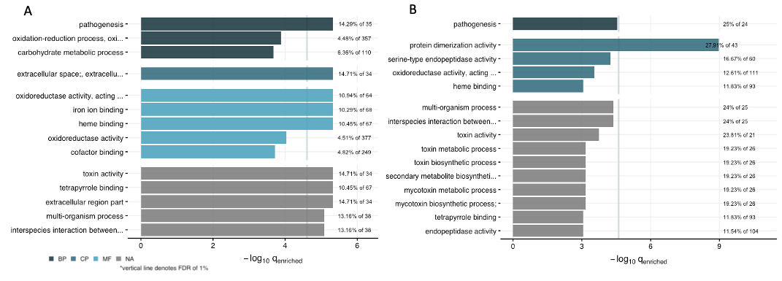

**Figure 4 : Enrichment of non-expressed genes**. The x-axis represents the false discovery rate of the enriched terms as -log10 of the q-value. On the y-axis, the enriched GO terms are A) Out of the 7455 protein-coding sequences in O. camponoti-floridani, 190 genes were not expressed, which are enriched in processes including pathogenesis, oxidoreductase activity, and toxin metabolism. B) Out of 10364 genes in B. bassiana, 756 (7.3%) genes were not expressed, which are enriched in similar processes as O. camponoti-floridani. Additionally, these genes were enriched in the cellular process of protein dimerization. The enrichments are categorized in biological, cellular, and molecular processes, and are referred to by BP, CP, and MP respectively. Enrichments without an annotated process are placed in the category not applicable (NA)

**Figure 4 : Enrichment of non-expressed genes**. The x-axis represents the false discovery rate of the enriched terms as -log10 of the q-value. On the y-axis, the enriched GO terms are A) Out of the 7455 protein-coding sequences in O. camponoti-floridani, 190 genes were not expressed, which are enriched in processes including pathogenesis, oxidoreductase activity, and toxin metabolism. B) Out of 10364 genes in B. bassiana, 756 (7.3%) genes were not expressed, which are enriched in similar processes as O. camponoti-floridani. Additionally, these genes were enriched in the cellular process of protein dimerization. The enrichments are categorized in biological, cellular, and molecular processes, and are referred to by BP, CP, and MP respectively. Enrichments without an annotated process are placed in the category not applicable (NA)

However, finding the terms enriched in non-expressed genes also does not necessarily mean that all genes regarding pathogenesis processes are not expressed. Robust mechanisms like clock gene expression and clock-driven expression of genes might still be expressed. Additionally, the media that is used does resemble ant hemolymph so this might still trigger some of the same responses as when it would once the fungus is inside an ant. For instance, genes that need to be quickly upregulated upon infection might not be completely off to facilitate that switch.

## **2.3 Rhythmicity analysis**

2.3.1 O. camponoti-floridani

To identify genes that show daily rhythms in expression levels, oscillating every 8, 12, or 24 hours, we used the non-parametric algorithm empirical JTK Cycle eJTK and refer to them as 24h, 12h, or 8h rhythmic genes (Hutchison et al. 2015). Of the 6889 genes expressed in *O. camponoti-floridani* we identified 2285, 391, and 245 genes as 24 hours, 12 hours, and 8 hours rhythmic, respectively (S1, columns ‘8h, 12h, and 12h, rhythmic’). Two genes (locus tags GQ602_000751 and GQ602_007047) were identified as both 8h and 24h rhythmic and four genes (locus tags GQ602_002203, GQ602_003746, GQ602_003808, and GQ602_005267) as both 12h and 24h rhythmic. Subsequently, we performed functional enrichment analysis on the genes identified as 24h, 12h, and 8h rhythmic, based on the PFAM, GO, SSP, SignalP, THMHH, and TF annotations (explained in Methods). Out of the 2285 24h rhythmic genes, 46 annotation terms, including PFAM, GO, TF, and THMHH were overrepresented in the enrichment analysis. We expected to find a variety of enriched terms since our test set (24h rhythmic genes) contained almost 2300 genes, which is a third of all the expressed genes in the transcriptome of *O. camponoti-floridani.* Furthermore, we expect oscillating gene transcript to be important for various basic molecular, cellular, and biological processes in fungi (Bell-Pedersen, Garceau, and Loros 1996). The 24h-rhythmic genes in *O. camponoti-floridani* were enriched in transport and localization, protein modifications, and protein activity (S7, sheet 1). Additionally, kinase activity is overrepresented (GO:0000155|phosphorelay sensor kinase activity, GO:0004673|protein histidine kinase activity, GO:0004672|protein kinase activity, and GO:0016301|kinase activity) with 42% (53 out of 127) of the genes annotated as such in the genome, having 24h rhythmic expression. Kinases are key players for maintaining oscillations in protein activity and the working of circadian feedback loops, such as the TTFL in *N. crassa* (Rosato, Tauber, and Kyriacou 2006). Enrichment analysis of 12h rhythmic and 8h rhythmic genes, did not yield overrepresented terms, which could be the result of the smaller test set size in combination with oscillating transcripts dispersing in function (S7, sheet 2&3). Enrichment analyses with the rhythmic genes as background might help to elucidate the processes involved in the 12h and 8h rhythmic genes. The study of de Bekker et al. (2017), did a similar analysis into rhythmicity of genes in *O. kimflemingiae,* where RNA-sequencing was performed over 48h with a resolution of 4h. We compared the 24h rhythmic genes we found *O. camponoti-floridani* with the homologs in *O. kimflemingiae* and checked if there was an overlap in 24h rhythmic genes. We found that 343 homologous genes were identified as 24h rhythmic in both *O. camponoti-floridani* and *O. kimflemingiae* (Figure 5). We used fisher’s exact test, to test whether this overlap was significant or found by mere chance, which resulted to be statistically significant (p-value = 2.2e-16) (Fay, 2010).

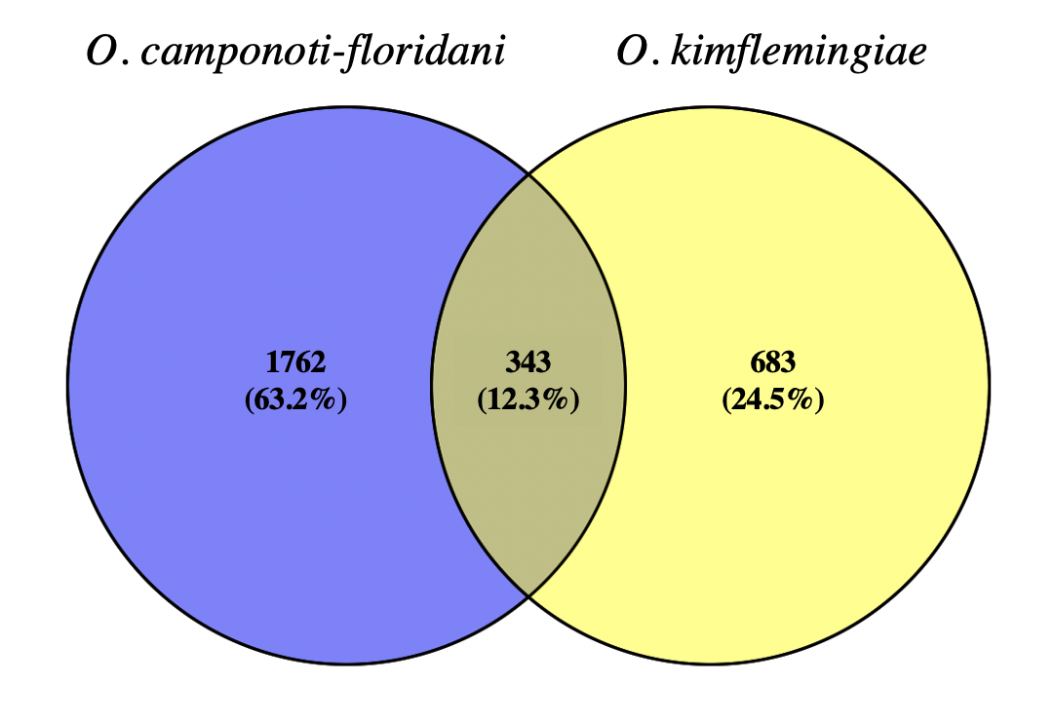

**Figure 5: Overlap of 24h rhythmic genes in O. camponoti-floridani and O. kimflemingiae.** Of the 2285 genes identified as 24h rhythmic in O. camponoti-floridani, we found 2105 genes to have a unique homolog in O. kimflemingiae (blue left circle). Out of the 2105 genes O. camponoti-floridani, we found 343 genes to also have a 24h rhythmic gene expression in O. kimflemingiae, which is significantly overlapping (p-value = 2.2e-16).

Next, we investigated the 24h-rhythmic genes that peak during the subjective day (or night) and the biological functions they perform. We applied an agglomerative hierarchical clustering framework to identify clusters of co-expressed genes with peak activity at certain times of the day, such as ‘night-‘ or ‘day peaking’ genes (Figure 6). Subsequently, we performed enrichment analysis on the different clusters of day/night-peaking genes to investigate the biological processes these might be involved in (S4). The genes with a diurnal rhythm of 24h could roughly be clustered in four clusters (Figure 6A) (S5, sheet 1). One contained the day-peaking genes (633 genes) (cluster 4, light grey box) and one the night-peaking genes (833 genes) (cluster 1, dark grey box). The other two clusters contained mixed signals for day and night peaking genes. The day-peaking cluster was enriched in 109 terms, which include multiple biological and cellular processes regarding biosynthesis, metabolism, DNA, RNA, and translation. Similar terms, such as metabolic processes and RNA-related processes, are also upregulated in parasitic fungi *Pseudogymnoascus destructans* when grown in culture (Reeder et al. 2017). Interestingly, we found 6 of the 7 *O. camponoti-floridani* genes annotated with glycosyl metabolic function (GO:1901657) in the day-peaking gene set. Glycosyl hydrolases catalyze the hydrolysis of glycosidic bonds in complex sugars, which are related to host cell wall degradation (Davies and Henrissat 1995). During a time-course study of *Marssonina brunnea* infecting poplar leaves, which causes leaf spots, 19 glycosyl hydrolases were significantly differentially expressed in a later stage of infection (Chen et al. 2015). Moreover, chitinases belong to glycosyl hydrolase family and are found in entomopathogens, such as *B. bassiana,* where overexpression led to increased virulence (Dong, Yang, and Zhang 2007; Fan et al. 2007). Chitin is an important compound of the cuticle of an insect, which serves as physical and chemical barriers protecting the insect from dehydration, mechanical injury, and predation, but is also found but also on the inside of the insect supporting the epidermis, trachea, and gut epithelium (Muthukrishnan et al. 2020). In *O. camponoti-floridani,* the chitinases might serve to make the ants cuticle less rigid, which might be 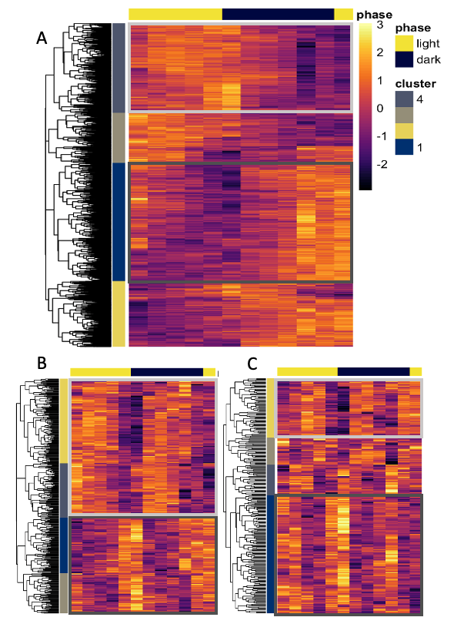important during the final ‘death grip’, just like muscle degradation and alteration is also shown in *O. unilateralis* *s.l* infected ants and suggested to play a role in causing the ‘death-grip’ (Hughes et al. 2011).

**Figure 6: Rhythmic gene expression of O. camponoti-floridani** Heatmaps show the gene expression of A) 24h rhythmic genes B) 12h rhythmic genes and C) 8h rhythmic genes over a period from 24 hours in 12:12 L:D conditions indicated by the top bar phase. Each row represents a single gene, each column represents the Zeitgeber Time (ZT) at which the sample was collected, shown in chronological order from left to right (from ZT2 to ZT24, every 2h). The expression value is represented by a color scale the ranges from bright yellow, which means high expression values, to dark purple, meaning low expression values. We clustered the genes in four clusters based on similarity in gene expression with a hierarchical clustering algorithm and visualized it with dendrograms. Light grey and dark grey boxes represent clusters with different peak activities (e.g. night or day peaking activity). A) For 24h rhythmic genes we identified a day peaking cluster (cluster 4, light grey box) and a night peaking cluster (cluster 1, dark grey box). B) For 12h rhythmic genes we identified two clusters with a peaking activity during the day and the night (cluster 2&4, light grey box) and two clusters peaking during dush and dawn (cluster 1&3, dark grey box). C) For 8 rhythmic genes we identified one dusk downregulated cluster (cluster 2 light grey box) and one dusk upregulated cluster (cluster 1, dark grey box).

**Figure 6: Rhythmic gene expression of O. camponoti-floridani** Heatmaps show the gene expression of A) 24h rhythmic genes B) 12h rhythmic genes and C) 8h rhythmic genes over a period from 24 hours in 12:12 L:D conditions indicated by the top bar phase. Each row represents a single gene, each column represents the Zeitgeber Time (ZT) at which the sample was collected, shown in chronological order from left to right (from ZT2 to ZT24, every 2h). The expression value is represented by a color scale the ranges from bright yellow, which means high expression values, to dark purple, meaning low expression values. We clustered the genes in four clusters based on similarity in gene expression with a hierarchical clustering algorithm and visualized it with dendrograms. Light grey and dark grey boxes represent clusters with different peak activities (e.g. night or day peaking activity). A) For 24h rhythmic genes we identified a day peaking cluster (cluster 4, light grey box) and a night peaking cluster (cluster 1, dark grey box). B) For 12h rhythmic genes we identified two clusters with a peaking activity during the day and the night (cluster 2&4, light grey box) and two clusters peaking during dush and dawn (cluster 1&3, dark grey box). C) For 8 rhythmic genes we identified one dusk downregulated cluster (cluster 2 light grey box) and one dusk upregulated cluster (cluster 1, dark grey box).

In the night-peaking (cluster 1), 68 annotation terms were enriched, including PFAMs, GOs, TFs, and TMHMM, involved in various biosynthesis, localization, and membrane-related processes (S4, sheet 2). Surprisingly, we did not find proteins with a secretion signal to be enriched in the night-peaking genes, while we do find this enrichment in the night-peaking genes in *O. kimflemingiae* (de Bekker, et al. 2017)*.* Therefore, we also searched for overlapping 24h rhythmic genes with a night-peaking activity between *O. camponoti-floridani* and *O. kimflemingiae,* which resulted in 9 overlapping genes (p-value = 0.85)(Figure 7)*.* This either shows that there is little overlap between 24h rhythmic genes with a night-peaking between *O. camponoti-floridani* and *O. kimflemingiae,* or that comparison of clusters based on hierarchical clustering between species might be tricky since these are partially chosen upon visual inspection. It is therefore desirable to use other clustering methods as well.

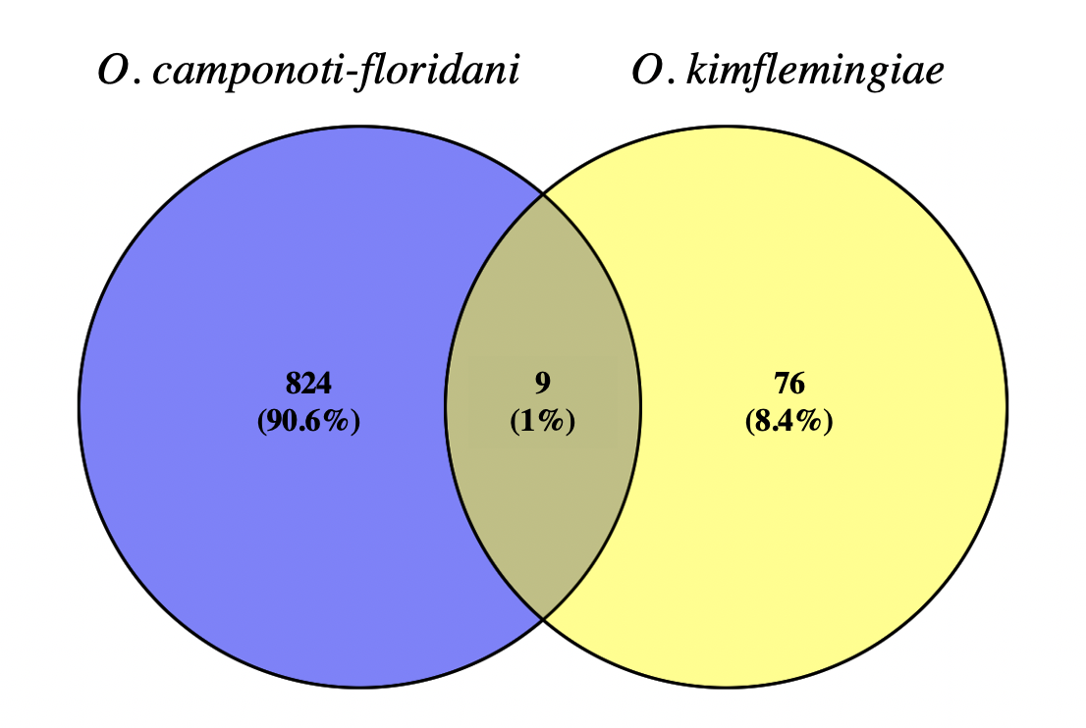

**Figure 7:** **Overlap of 24h rhythmic genes with a night-peaking activity in O. camponoti-floridani and O. kimflemingiae.** Out of the 833 24h rhythmic genes in O. camponoti-floridani which had a peaking activity during the night, only 9 were also overlapping with the 85 night-peaking genes in O. kimflemingiae (p-value =0.86).

Genes with an ultradian rhythm of 12h, could be clustered into two clusters that either had a peaking activity during the day and during the night (Figure 6B, cluster 2&4 light-grey box) or dusk and dawn (Figure 6B, cluster 1&3 dark-grey box) (S5, sheet 2). We refer to these as ‘day&night’ and ‘dusk&dawn’ peaking clusters. Out of the 232 genes in the ‘day&night’ peaking cluster, 41 GO annotation terms were enriched for processes regarding RNA and DNA housekeeping, along with other general biosynthesis and metabolic processes (S4, sheet 3). In the ‘dusk&dawn’ peaking cluster, out of the 159 genes no enrichments were found (S4, sheet 4). The genes with an oscillating pattern of 8h could also be clustered into four clusters. We identified a cluster in which most genes are highly expressed at ZT 10-12, which represents the subjective dusk phase of the day (Figure 6C, cluster 1, dark grey box). Contrary, there seems to be a cluster that is particularly downregulated during this phase, since all the genes in this cluster color very dark (Figure 6C, cluster 2, light grey box). Enrichment for both these clusters (consisting out of 124 genes, and 63 genes, respectively) did not yield overrepresented annotations terms (S4, sheet 5&6).

2.3.2 B. bassiana

Using the same procedure as above, we identified rhythmic genesin *B. bassiana* that peak at different time-of-day and performed functional enrichment analysis to infer their

biological role*.* Of the 9006 *B. bassiana* genes expressed in culture,1872 (21%) genes showed significant 24h rhythms and were overrepresented in 107 GO annotated terms (S7, sheet 4). These terms included a wide variety of molecular, cellular, and biological processes, one-third of which is involved in binding activities. For instance, enriched GTPase binding activity might suggest that complex signaling cascades are involved in 24h rhythms processes. Subsequently, we clustered the 24h rhythmic genes into four clusters (S6, sheet 1) (Figure 8A). Out of the four clusters, we could identify one smaller cluster (218 genes) as day peaking genes (Figure 8A, light grey box) and one bigger cluster (767 genes) as night peaking genes (Figure 8A, cluster 1, dark grey box). The other two clusters had mixed signals for day and night peaking genes. Enrichment analysis of the day peaking cluster resulted in 22 enriched terms, among which the majority is involved in processes related to RNA and translation (S4, sheet 7). The night peaking genes were enriched in 107 terms with a wide variety of involved processes, including molecular processes as protein binding, modification, and activity, along with metabolic, biosynthesis, and transport processes (S4, sheet 8).

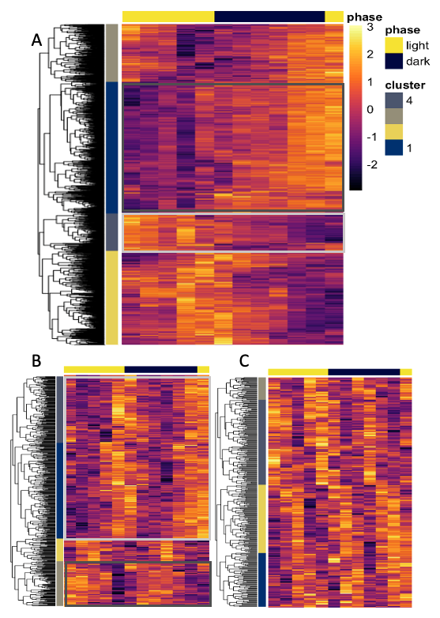For the ultradian rhythmic genes, we identified 441 genes as 12h rhythmic (Figure 8) and 327 genes as 8h rhythmic (Figure 8C). Enrichment analysis on the 8h rhythmic genes did not yield in enriched terms, while surprisingly 18 terms were overrepresented in the 12h rhythmic gene set. However, each enriched term in our 12h rhythmic gene set did not comprehend more than 8% of the total number of genes annotated with that term in the genome. Subsequently, we clustered the gene sets into four (S6, sheets 2&3). We found two clusters containing ‘dusk&dawn’ peaking genes (312 genes) with a 12h rhythm (Figure 3B, light grey box). These clustered were only enrichened in one term, namely an anticodon binding domain (S4, sheet 9). Additionally, we found a cluster that seem to be primarily downregulated during the dusk phase, hence the black coloring in the heatmap around ZT 10 (Figure 8B, cluster 3, dark grey box). This cluster contained 86 genes, for which 10 terms were enriched in metabolic, biosynthesis, and translational processes. Interestingly, the second-highest enriched term in this set was related to the organonitrogen compound biosynthetic process (S4, sheet 10). This process was also found enriched in differentially expressed genes of *Fusarium oxysporum* treated with canthin-6-one, an antimicrobial compound, so it might be important to counteract host immunity during infection (Li, Zhao, and Zhang 2021). Additionally, genes annotated with the organonitrogen compound biosynthetic process were found to be enriched in significantly upregulated genes of *P. destructans* during infection of*, Myotis lucifugus* (North American bat species) (Reeder et al. 2017).

**Figure 8:** **Rhythmic gene expression of B. bassiana** Heatmaps show the gene expression of A) 24h rhythmic genes B) 12h rhythmic genes and C) 8h rhythmic genes over a period from 24 hours in 12:12 L:D conditions indicated by the top bar phase. Each row represents the Zeitgeber Time (ZT) at which the sample was collected, shown in chronological order from left to right (from ZT2 to ZT24, every 2h. Each row represents a single gene, each column the sample time (e.g. 2h, 4h, 6h, and so on) and the phase of the L:D cycle. The expression value is represented by a color scale the ranges from bright yellow, which means highly upregulated, to dark purple, meaning highly downregulated. We clustered the genes in four clusters based on similarity in gene expression with a hierarchical clustering algorithm and visualized it with dendrograms. Light grey and dark grey boxes represent clusters with different peak activities (e.g. night or day peaking activity). A) For 24h rhythmic genes we identified a day peaking cluster (cluster 4, light grey box) and a night peaking cluster (cluster 1, dark grey box). B) For 12h rhythmic genes we identified two clusters that have a peak activity during dusk and dawn (cluster 1 and 4 light grey box) and one dusk downregulated cluster (cluster 3, dark grey box). C) For 8 rhythmic genes we identified did not identify clusters with peaking activity, since the signals in each cluster were mixed.

**Figure 8:** **Rhythmic gene expression of B. bassiana** Heatmaps show the gene expression of A) 24h rhythmic genes B) 12h rhythmic genes and C) 8h rhythmic genes over a period from 24 hours in 12:12 L:D conditions indicated by the top bar phase. Each row represents the Zeitgeber Time (ZT) at which the sample was collected, shown in chronological order from left to right (from ZT2 to ZT24, every 2h. Each row represents a single gene, each column the sample time (e.g. 2h, 4h, 6h, and so on) and the phase of the L:D cycle. The expression value is represented by a color scale the ranges from bright yellow, which means highly upregulated, to dark purple, meaning highly downregulated. We clustered the genes in four clusters based on similarity in gene expression with a hierarchical clustering algorithm and visualized it with dendrograms. Light grey and dark grey boxes represent clusters with different peak activities (e.g. night or day peaking activity). A) For 24h rhythmic genes we identified a day peaking cluster (cluster 4, light grey box) and a night peaking cluster (cluster 1, dark grey box). B) For 12h rhythmic genes we identified two clusters that have a peak activity during dusk and dawn (cluster 1 and 4 light grey box) and one dusk downregulated cluster (cluster 3, dark grey box). C) For 8 rhythmic genes we identified did not identify clusters with peaking activity, since the signals in each cluster were mixed.

The clusters containing the 8h rhythmic genes had mixed signals, from which we could not define a rough peak activity and therefore did not perform enrichment.

## 2.3.3 Comparing 24h rhythmic genes of O. camponoti-floridani and B. bassiana

The behavior-manipulating specialist *O. camponoti-floridani* and generalist *B. bassiana* have both very different infection runs, once inside the ant. In the lab, *O. camponoti-floridani* infection can take up to 25 days, whereas *B. bassiana* infection only takes 5 (Trinh, Oulette, and de Bekker 2020). Since *B. bassiana* kills and consumes its host within a matter of days upon infection, without causing obvious pathogen-adaptive behavior in the host, it could be considered a necrotrophic lifestyle. On the contrary, *O. camponoti-floridani*, which only infects *C. floridanus,* spends more time in a symbiotic relationship before killing its host, which could be considered more a hemibiotrophic lifestyle (de Bekker, Beckerson, and Elya 2021). To investigate differences and similarities in *O. camponoti-floridani* and *B. bassiana*, we compared the enrichment results of the 24h rhythmic genes in both fungi. Here we found 46 terms enriched in *O. camponoti-floridani*, and 107 terms in *B. bassiana*. Of these terms, 22 were overlapping (p-value = 0.32), including PFAM, GO, and TF annotations (S10) (Figure 9). These terms concerned phosphorylation processes (e.g. kinase activity, phosphorelay sensor kinase activity, phosphotransferase activity), modification processes (e.g. protein modification, cellular protein modification), and regulation processes (e.g. regulation of cellular process, signal transduction, biological regulation). Despite that the overlap is not significant, these terms still might be involved in maintaining the general feedback loops of clock (-controlled) genes, which function in both fungi.

The terms only enriched in *O. camponoti-floridani* are related to transport (e.g. transporter activity, sulfate transport, transmembrane transport), localization (e.g. localization, establishment of localization), and membrane processes (e.g. integral component of membrane, membrane part). We could question whether these processes might describe a hemibiotrophic lifestyle, which is based on a more complex interaction with the host instead of taking it all at once. For instance, hexose transporters are involved in the different stages in pathogenesis of the hemibiotrophic maize pathogen *Colletotrichum graminicola* (Lingner et al. 2011).

The terms only enriched in *B. bassiana* were mainly involved in binding processes (e.g. GO:0005515|protein binding, GO:0043168|anion binding, GO:0030554|adenyl nucleotide-binding), or regulation processes (e.g. GO:0051171|regulation of nitrogen compound metabolic process, GO:0009889|regulation of biosynthetic process, GO:0097367|carbohydrate derivative binding), which might describe a necrotrophic lifestyle.

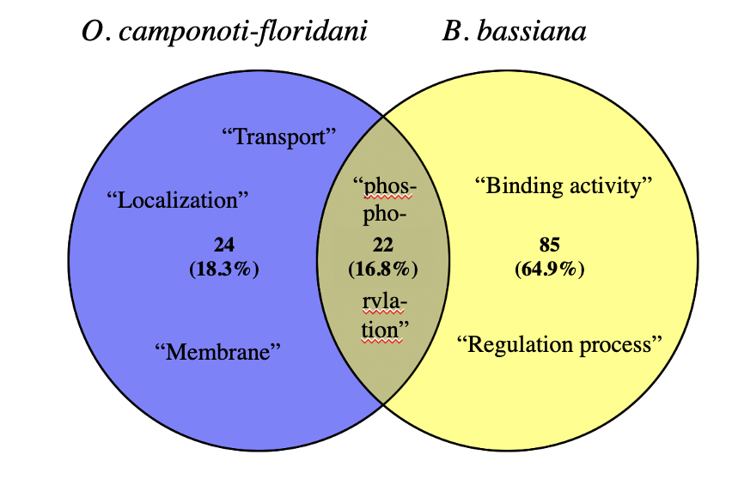

**Figure 9: Overlapping enrichment term in O. camponoti-floridani and B. bassiana.** We compared the enriched terms from the 24h rhythmic genes set of O. camponoti-floridani with B. bassianaand found 22 overlapping terms (p-value = 0.32). These seem to be involved in phosphorylation processes. Terms only found in O. camponoti-floridani seem to be membrane and transport related, while B. bassiana has a lot of binding activity terms enriched.

2.3.4 Conclusion

We analyzed the gene expression values of *O. camponoti-floridani* and *B. bassiana* over 24 hours of blastospores growth in liquid culture. We identified genes that showed a significantly oscillating gene expression pattern of 24h, 12, or 8h, and refers to them as 24h, 12h, and 8h, rhythmic genes. Subsequently, we clustered rhythmically expressed genes based on similarity in expression and identified groups of genes with different peak activity during the day (e.g. day- or night-peaking) and performed enrichment analysis. In *O. camponoti-floridani,* we speculate proteins belonging to the hydrolase family as putatively involved during infection*.* They might act in degradation and alteration of internal tissues in the ants, previously also suggested to be involved in the ‘death-grip’.

Surprisingly, we did not find enrichments for secreted proteins, while would expect manipulated behavior to be caused by the secretion of compounds. For instance, secreted proteins were found to correlate with neuronal function in the ant. Dysregulation of host neuronal activities, including neurotransmitters, are a plausible strategy to manipulate host behavior (Will, et al. 2020). In addition, unexpectedly, we also found little overlap between 24h rhythmically expressed genes that we grouped based on their night-peaking in *O. camponoti-floridani* and *O. kimflemingiae.* Therefore, a different clustering method would be desirable, to better investigate genes with a rhythmic expression and their peak activity.

Furthermore, we find differences in processes that might be regulated by 24h rhythmic genes in *O. camponoti-floridani* and *B. bassiana.* These differences include transport-related processes in *O. camponoti-floridani*, and binding activity in *B. bassiana,* which might be related to the differences in the infection strategy of both fungi.

## **2.4 Co-expressed modules of genes in *O. camponoti-floridani* and *B. bassiana***

To better investigate and provide an overview of co-expressed groups of genes, we performed network analysis using Weighted Gene Co-expression Network Analysis (WGCNA). The advantage of network analysis is the usage of soft thresholding to group genes together, which minimizes information loss and increases sensitivity (Carter et al. 2004). We describe groups of co-expressed gene networks, referred to as modules, containing 24h, 12h, or 8h oscillating transcripts and how these modules to each other. We subsequently characterized these modules based on their peak activity (e.g. day- or night-peaking) and enrichment analyses.

2.4.1 O. camponoti-floridani

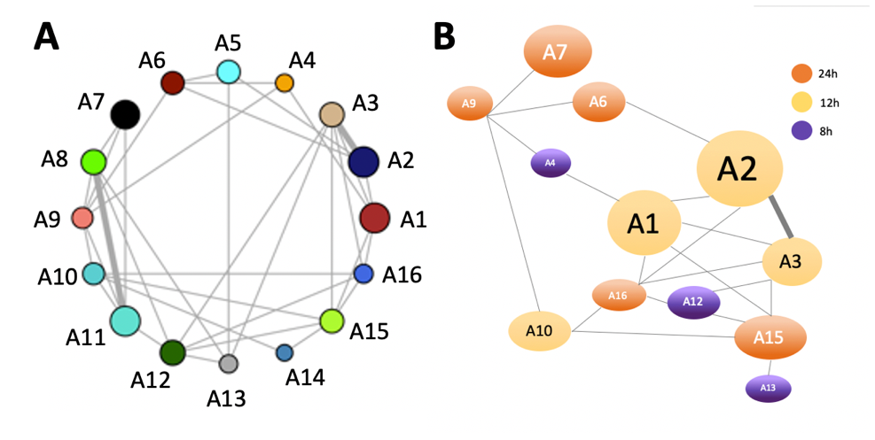Using WGCNA, we constructed the daily gene expression network of *O. camponoti-floridani* and identified 16 modules of co-expressed genes, which were named A1 till A16 (Figure 10A). Next, we annotated the network with the genes we considered highly interesting, namely genes with 24h, 12h, or 8h rhythmic expression patterns. We found modules that were significantly positively correlated with the 24h, 12h, or 8h rhythmic gene set based on overlapping genes with Fisher’s exact test, and refer to them as ‘rhythmic modules’ (Figure 10B&11). Identifying the rhythmic modules helps to give gain insight into which genes possibly also have a rhythmic expression or are rhythmically regulated to some extent, which were missed by hard thresholding in our rhythmicity analysis. We hypothesize that genes in the same module, are regulated in the same manner because they seem to be co-expressed. Therefore, when a cluster has a significant overlap with our identified rhythmic genes, we might consider the whole cluster as rhythmically expressed or rhythmically regulated. We found the modules A1, A2, A3, and A10 to be positively correlated with the 24h rhythmic genes (yellow nodes in figure 10B). Modules A1, A2, and A3 cluster tightly together in the network, showing a strong correlation to each other. All these modules have a peak expression during the subjective night phase and were connected closely in the network (Figure 12A, B, and C). Alternatively, module A10 is less connected which might be related to its peaking activity during dusk (Figure 12D). Additionally, module A10 is the smallest 24 rhythmic module and did not yield any enriched terms (S8, sheet 3).

**Figure 10: Network of co-expressed genes in** **O. camponoti-floridani.** A) With WGCNA we generated a network containing 16 clustered groups of co-expressed genes (modules). B) Network of modules identified as rhythmic modules based on overlapping genes with a rhythmic gene expression. Nodes in the network represent modules of co-expressed genes, where the bigger size of the node corresponds to a higher number of genes present in the module. The edges show the correlation between the modules, where the more thickness correspond to a stronger correlation.

*Figure 10: Network of co-expressed genes in* O. camponoti-floridani. *A) With WGCNA we generated a network containing 16 clustered groups of co-expressed genes (modules). B) Network of modules identified as rhythmic modules based on overlapping genes with a rhythmic gene expression. Nodes in the network represent modules of co-expressed genes, where the bigger size of the node corresponds to a higher number of genes present in the module. The edges show the corre*1. Introduction 4

2. Results & Discussion 7

**2.1 Clock (-controlled) genes in *O. camponoti-floridani* and *B. bassiana*** 7

2.1.1 Clock components

2.1.2 Photoreceptors

2.1.3 Conculsion

**2.2. Non-expressed genes in *O. camponoti-floridani* and *B. bassiana*** 12

2.2 Conclusion 13

**2.3 Rhythmicity analysis** 13

2.3.1 *O. camponoti-floridani*

2.3.2 *B. bassiana*

2.3.3 Comparing 24 rhytmic genes

2.3.4 Conclusion

**2.4 Co-expressed modules of genes in *O. camponoti-floridani* and *B. bassiana*** 20

2.4.1 *O. camponoti-floridani*

2.4.2 *B. bassiana*

2.4.3 Conclusion

**2.5 Differentially expressed genes during manipulation and their rhythmicity** 25

2.5.1 *O. camponoti-floridani*

2.5.2 *B. bassiana*

2.5.3 Conclusion

Conclusion & Future avenues ------- 28

Supplementary info ------------------- 29

References ------------------------------ 29

lation between the modules, where the more thickness correspond to a stronger correlation.

In module A3, the majority of the genes were identified as 24h rhythmic (55%), while the other modules (A1, A2, and A10) contained around 40% genes identified as 24h rhythmic (Figure 11). Two of these modules (A1 and A2) were large modules, containing 1144 and 1316 genes respectively. This suggests that many genes are co-expressed with a 24h rhythmic expression pattern and could potentially be regulated by circadian rhythms or day-night rhythms in light availability. Module A1 and A2 were significantly enriched in various biological and cellular processes, along with

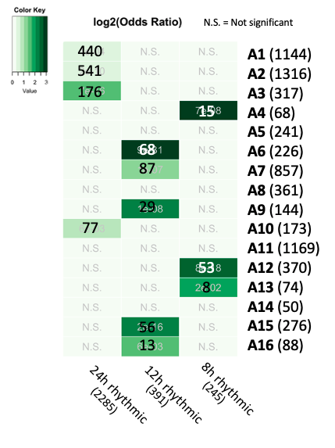

**Figure 11: Rhythmic modules in O. camponoti-floridani.** We analyzed the genes in O. camponoti-floridani based on their co-expression with WGCNA which resulted in a network of 16 modules (clusters of co-expressed genes). We performed Fisher’s exact test to identify if the genes in a given module had a significant overlap with either 24h, 12h, or 8, rhythmic genes. The log Odds ratio is given by color. The higher the log Odds ratio, the darker green, which means the less likely we find this overlap by mere chance. For the module in which we found a significant overlap, we include the number of genes that overlap with the p-value. The other numbers represent the number of genes in the module or rhythmic gene set

proteins containing a transmembrane domain (TMHMM). In module A1, 23% of the genes contained a TMHMM and, in module A2 24% (S8, sheet 2&4). In addition, nigh-peaking module A3, which had the highest rhythmic gene overlap, contained 27% of the genes a TMHMM (S8, sheet 1). This is in line with our previous finding of the hierarchical clustering, in which TMHMM’s were also enriched 24h rhythmically night peaking genes in *O. camponoti-floridani*. This suggests that transmembrane proteins possibly be regulated by circadian rhythms and are functional during the night. Numerous studies showed the importance of transmembrane protein in the virulence of viruses (Bronnimann, et al. 2013; Hevia, et al. 2015; Machamer, et al. 2006; Schubert, et al. 1996; Ye, et al. 2007). Moreover, transmembrane proteins are also found to be involved in the virulence of fungal (plant and human) pathogens (Banks, et al. 2005; Chen, et al. 2006). However, the body of experimental evidence of transmembrane protein and its role in virulence is available to a lesser extent for entomopathogens. More investigation into transmembrane and their role during infection by entomopathogens might be interesting.

Interestingly, we found small secreted protein to be enriched in modules A1 and A2, which have a night-peaking activity. Small secreted proteins are potentially very important during infection and manipulation. In *O. kimflemingiae,* (small) secreted proteins are also enriched in 24h rhythmic genes with a night-peaking activity (de Bekker, et al. 2017).

Interestingly, none of the 24h rhythmic modules had day peaking activity. This suggests that the day peaking genes might be more scattered between modules and might be regulated by more different pathways. Moreover, it shows that night peaking genes might be important for the infection strategy of *O. camponoti-floridani,* which could hypothetically be correlated with the physiology of the ant. For instance, the virulence of *B. cinerea* is synchronized to reach its highest point when its host *A. thaliana* is most susceptible, namely during dusk (Hevia et al. 2015).It would be highly interesting to examine the 24h rhythmic gene expression in *C. floridanus* as well, to search whether there might be a correlation.For example, we question if the nocturnal nature of *C. floridanus* could be correlated to night-active genes in *O. camponoti-floridani* and whether there might be linked to establishing infection.

We also found five modules (A6, A7, A9, A15, and A16) overlapping with 12h rhythmic genes (Figure 10B orange nodes). These modules Module A6 had the highest significant overlap with the 12h rhythmic genes. This module had peak activity right after the light was turned off and when they were turned back on (Figure 12). This suggests that this module might be regulated by the sudden change of light. Enrichment of this module led to 43 enriched terms, mainly involved in various DNA, RNA, and protein binding activities, such as purine, ribonucleotide, and Ras GTPase binding (S8, sheet 5). Module A15 was more distantly connected to the majority of the 12h rhythmic module, which might be the result of the somewhat antagonistic expression to module A6, namely a clear downregulation when the light was turned off (Figure 12).

Four out of the five 12h rhythmic modules, were enriched for small secreted proteins and proteins with a secretion signal. This suggests that some proteins might be secreted with a 12h oscillating pattern, which possibly could be clock or light-regulated. Because modules A16 and A9 had a rather low number of overlapping genes (<50), we were not able to discuss these genes in detail of gene expression patterns.

For 8h rhythmic modules, module A12 contained 21% of all the genes identified as 8h rhythmic. However, this module did not yield any enriched terms.

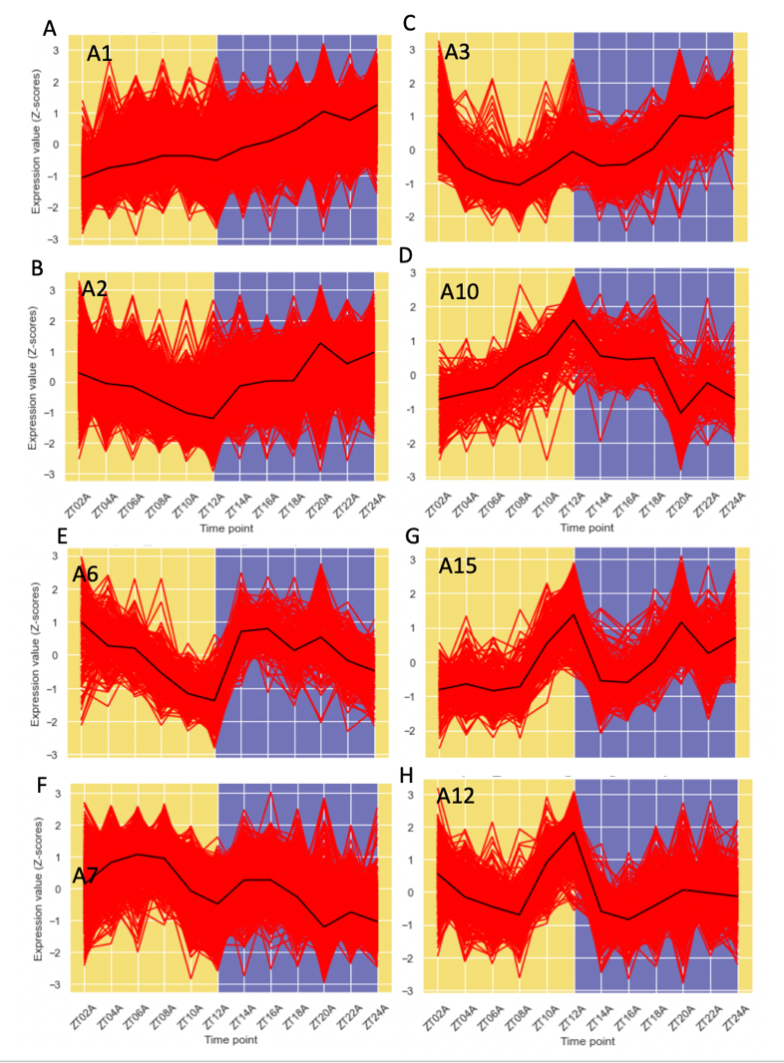Again, since we find putative (small) secreted proteins in most of our rhythmic modules, we hypothesize that these could be clock-regulated or light-regulated which possibly could contribute to their effectiveness during infecting and manipulation.

**Figure 12: Gene expression pattern of rhythmic modules in O. camponoti-floridani.** The expression values in z-score, obtained by RNA seq over 24h with a 2h resolution, of each gene in a module are plotted as red lines and the black line represents the median of the z-score values. The x-axis represents the time points of sampling, ZT2 till ZT24, and the y-axis is the expression value in Z-score. The colored background indicates the subjective day- and night phase. A, B, C, and D, are 24h rhythmic modules; E, G, and F are the 12h rhythmic modules; and H is the 8h rhythmic module.

2.4.2 B. bassiana

For *B. bassiana,* we generated a network consisting out of 12 modules and named them B1 till B12 (Figure 13A). Subsequently, we annotated the network in the same manner as we did for *O. camponoti-floridani* (Figure13B&14)*.* We observed that the network with the rhythmic modules differentiates visually from *O. camponoti-floridani* (Figure 10). The 24h, 12h, and 8h rhythmic modules in *B. bassiana* are more intertwined with each other, with 24h rhythmic modules even partially being 12h or 8h rhythmic. Next, we performed enrichment analysis on the modules and found processes to nitrogen metabolism enriched in 24h rhythmic modules B6 and B10, which we also found in the ultradian gene set (discussed in section rhythmicity analysis). In the hierarchical clustering,we found the ultradian gene set lowly expressed during dusk, while the module B10 is highly expressed during dusk (section rhythmicity analysis). It might be that these processes are under clock control, but their activity at different time-of-day is driven by different sets of genes.

Examining the expression patterns of the 24h rhythmic modules, we observed day-, night- and dusk-peaking activities for the modules B2, B6, and B10 respectively (Figure 15 A, B, C), while the 24h rhythmic modules in *O. camponoti-floridani* had predominantly night-peaking activities. Inline

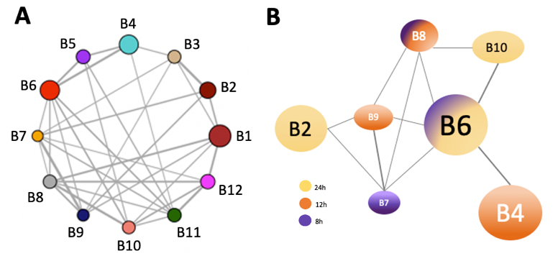 **Figure 13: Network of co-expressed genes in** **B. bassiana.**A) With WGCNA we generated a network containing 12 clustered groups of co-expressed genes (modules). B) Network of modules identified as rhythmic modules based on overlapping genes with a rhythmic gene expression. Nodes in the network represent modules of co-expressed genes, where the bigger size of the node corresponds to a higher number of genes present in the module. The edges show the correlation between the modules, where more thickness corresponds to a stronger correlation.

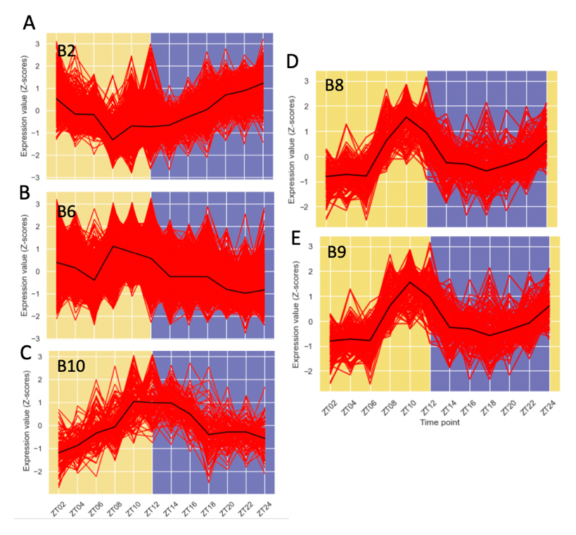with *O. camponoti-floridani,* all modules were enriched for SSPs, and the modules B2 and B6 for transmembrane proteins and could be involved

during infection (S9). We, therefore, speculate whether the difference between infection strategies might result in *O. camponoti-floridani* expression more secreted and transmembrane during the subjective night phase, while and *B. bassiana* expressed these genes throughout all phases of the day. If *O. camponoti-floridani* resembles more of a hemibiotrophic lifestyle, it might be of the essence to express genes involved in infection in a more sophisticated manner, which could also be correlated to the manipulated behavior. On the contrary, in the more necrotrophic lifestyle of *B. bassiana,* it might be that involved genes are expressed during the whole day, to consume the host in a short period.

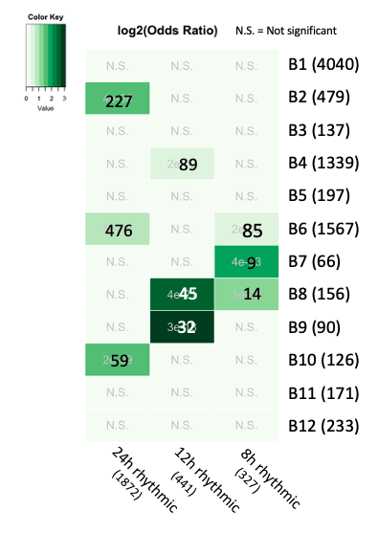

**Figure 14:** **Rhythmic modules in B. bassiana.** We analyzed the genes in B. bassiana based on their co-expression with WGCNA which resulted in a network of 12 modules (clusters of co-expressed genes). We performed Fisher’s exact test to identify if the genes in a given module had a significant overlap with either 24h, 12h, or 8, rhythmic genes. The log Odds ratio is given by color. The higher the log Odds ratio, the darker green, which means the less likely we find this overlap by mere chance. For the module in which we found a significant overlap, we include the number of genes that overlap with the p-value. The other numbers represent the number of genes in the module or rhythmic gene set.

**Figure 15: Gene expression pattern of rhythmic modules in B. bassiana.** The expression values in z-score, obtained by RNA seq over 24h with a 2h resolution, of each gene in a module are plotted as red lines and the black line represents the median of the z-score values. The x-axis represents the time points of sampling, ZT2 till ZT24, and the y-axis is the expression value in Z-score. The colored background indicates the subjective day- and night phase. A, B, and C, are 24h rhythmic modules; D, and E, are the 12h rhythmic modules

To see whether similar or different processes are related to peak activity of 24h oscillating transcripts in *O. camponoti-floridani* and *B. bassiana,* we compared the enrichment of modules with a similar expression profile. The module A10 in *O. camponoti-floridani* and B10 in *B. bassiana* both have peak activity at dusk. However, module A10 did not result in any enrichments. The other two similar-looking modules were A2 and B2, as both were downregulated during the subjective day phase and rose during the night phase. Module B2 was enriched in SSPs and TMHMMs, counting 6 (1%) and 128 (27%) genes containing these domains out of the 479 genes present in the module, respectively. Module A2 contained 1316 genes, of which 32 (2.5%) and 314 (24%) were annotated the SSPs and TMHMM, respectively, and found to be enriched in this module. Again, this strengthens our hypothesis that secreted proteins and transmembrane proteins might play an important role during infection.

We found three modules (B4, B8, and B9) with a significant overlap with the 12h rhythmically expressed genes. Although module B4 had the largest number of overlapping genes (89), the ratio was only 6.6%, which is rather low to identify the whole module as 12h rhythmic. Alternatively, both B8 and B9 contained 29% and 36% 12 rhythmic genes respectively, but the absolute number of overlapping genes was rather low (<50 genes). Both these modules show a similar expression pattern, with peaks at the subjective dawn and dusk, and troughs during the day and night (Figure 15). Additionally, both have a peak expression at ZT10, which is 2 hours before the light is turned off, thus the dusk phase. Since the modules are rather small, enrichment analysis did not yield over-represented terms (S9, sheet 4&5). This is in line with previous findings of peak activity during dusk. Enrichment analysis with only the rhythmic genes as background might help find processes involved in these ultradian rhythms.

The three 8h rhythmic modules contained too little genes (B7 had 9 and B8 had 14) or ratio (B6 contained 5.4%) to make biological meaningful statements about. In addition, module B6 contained a higher ratio of 24h rhythmic genes (30%) and could therefore better be considered 24h rhythmic. However, it is remarkable that we find rhythmic genes with different oscillating patterns in one module.

2.4.3 Conclusion

Here, we identified modules of highly co-expressed genes and investigated their expression pattern based on the presence of 24h, 12h, or 8h rhythmic genes in the module. We hypothesize that modules with a significantly high number of rhythmic genes are modules that can be identified as rhythmic modules, which might be clock or light/dark cycle regulated. The rhythmic modules in both fungi are enriched for putative (small) secreted proteins and transmembrane proteins, which we hypothesize to be important for infection. Interestingly, we observed predominantly night-peaking activity of the module in *O. camponoti-floridani,* while the rhythmic modules *B. bassiana* had peak expression throughout the day. We speculate whether this could be correlated to the different infection strategies between the fungi, with *O. camponoti-floridani* having a more hemibiotrophic lifestyle and *B. bassiana* a more necrotrophic.

## **2.5 Differentially expressed genes during manipulation and their rhythmicity**

2.5.1 O. camponoti-floridani

There is a great body of circumstantial evidence of 24h rhythms being involved in mechanisms underlying manipulated behavior caused by *Ophiocordyceps* (discussed in the Introduction).To explore the possible driving force of oscillating transcripts during manipulated behavior, we analyzed if previously identified differentially expressed genes (DEGs) in *O. camponoti-floridani* during manipulation showed diurnal, or ultradian expression patterns over 24h (Will et al. 2020). We hypothesized that at least a part of the genes upregulated during manipulation, have oscillating transcript levels because they are regulated by the clock and are involved in causing manipulated behavior, such as the ‘death grip’.

Previous transcriptomics study of Will, et al (2020) investigated mechanisms underlying the manipulated behavior of *C. floridanus* infected ants by *O. camponoti-floridani.* In this study, they obtained gene expression levels of *O. camponoti-floridani* during manipulation by sampling ants' heads when they demonstrated the manipulated biting behavior and subsequentially performed RNA sequencing. Additionally, they investigated expressed genes right after the death of the ant by infection and used *O. camponoti-floridani* grown as blastospore in liquid culture as control.

Since we hypothesized that circadian are involved during the manipulated behavior caused by *O. camponoti-floridani*, we questioned if the upregulated DEGs during manipulation are rhythmically expressed throughout 24h. Therefore, we performed Fisher’s exact test to find if there is a significant overlap between upregulated genes during manipulation and rhythmically expressed genes. Here, we found no significant overlap between 24h, 12h, or 8h rhythmic expressed genes (Figure 15A). This suggests that there is little overlap between upregulated genes and the rhythmic genes and/or that the upregulated are spread out between the 24h, 12, 8h rhythmic genes. Nonetheless did find 291 overlapping genes with 24h rhythmic expression patterns (p-value = 0.07), which still might include genes involved during manipulation. Since we also used network analysis to cluster genes in modules, we checked if certain modules had a significant overlap with upregulated genes during infection. The 24h rhythmic module A1 and the 12 rhythmic module A7 had a significant overlap with upregulated genes during manipulation (Figure 15B) (S10).

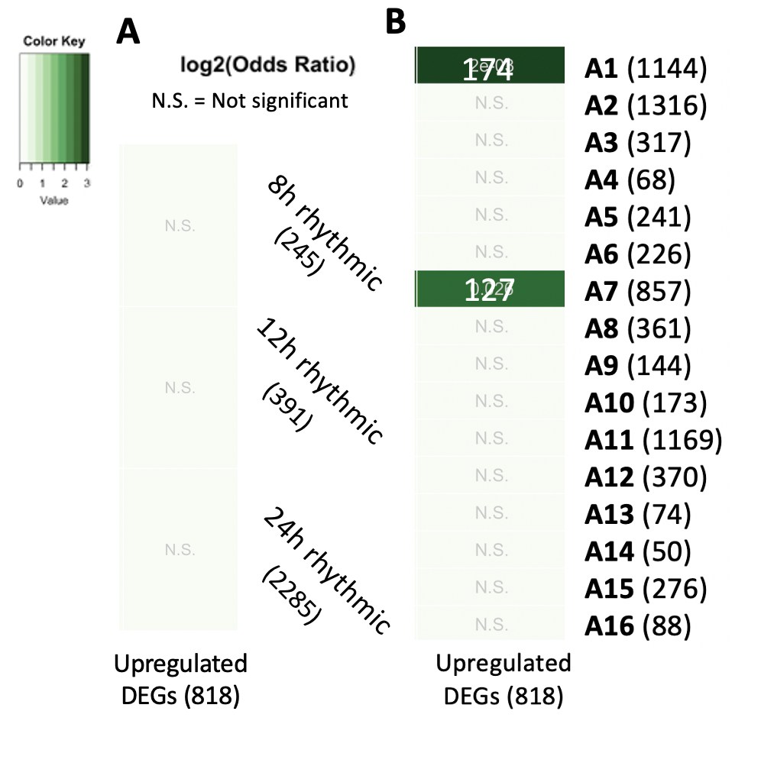

**Figure 15: Overlap of upregulated genes during manipulation in O. camponoti-floridani** with A) rhythmically expressed genes and B) network modules. The log Odds ratio is given by color and the number represents absolute gene counts. The 24h rhythmic module A1 and the 12h rhythmic module A7 have a significant overlap with genes that are upregulated during manipulation by O. camponoti-floridani.

The overlapping genes of module A1 included genes previously discussed to be important during infection, such as a putative enterotoxin, glycoside hydrolase family 3 protein, and a hexose transporter-like protein (S10). Interestingly, we found a protein-tyrosine phosphatase (PTP) within the overlapping genes. PTPs play a role in baculovirus infection and are suggested to be involved in manipulated behavior of infected caterpillars (Kamitaet al.2005; Katsumaet al.2012). Moreover, PTPs are also suggested to PTPs be involved in causing enhanced locomotion behavior by *Ophiocordyceps spp.* (de Bekker, et al. 2015; de Bekker, et al. 2017; Will, et al. 2020). In the overlapping genes with module A7, we found a heat-labile enterotoxin, which also might be involved during manipulated behavior. What the importance is of the aforementioned genes could be determined by gene deletion and monitoring the ant behavior during infection. More interesting target genes might also be found in the modules connected with modules A1 and A7.

Furthermore, we investigated the gene expression of previously identified as putative involved by Will, et al. (2020), such as ecdysteroids and serine proteases, but these were not found in our overlapping gene set. Additionally, secretome proteins like aflatrem, cyclase, and aflatoxin were also absent from the overlapping gene set.

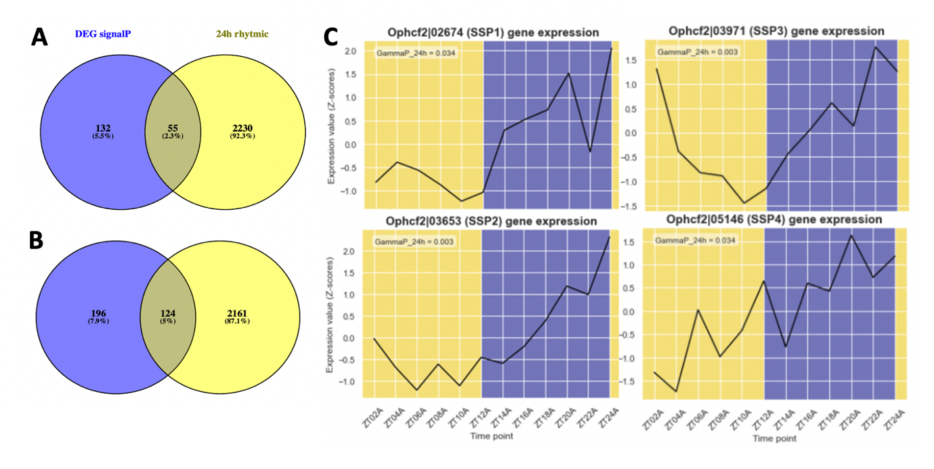Since multiple results and studies suggest that secreted and transmembrane proteins might important during manipulation by *O. camponoti-floridani*, we examined the overlap of these groups in more detail. We searched for genes 24h rhythmically expressed genes containing a secretion signal that are upregulated genes during manipulation. We found 55 genes with a 24h rhythmic expression to overlap with the upregulated genes during manipulation (p-value = 6.7e-16) (Figure 16A). This included four putative SSPs with a night-peaking activity (Ophcf2|02674, Ophcf2|03653, Ophcf2|03971, Ophcf2|05146), which is in line with the time-course data from *O. kimflemingiae* where night peaking genes were overrepresented for SSPs (de Bekker, et al. 2017) (Figure 16B). Alongside, we found 124 genes proteins containing a transmembrane that we 24h rhythmically expressed to be overlapping with the upregulated genes (p-value = 2.435e-16), which again included annotations for glycoside hydrolases (discussed in section rhythmicity analysis).

**Figure 16: Overlap of 24h rhythmic genes and upregulated genes during manipulation by O. camponoti-floridani** A) Only including genes with a secretion signal (p-value = 6.8e-16) and B) Only including genes with a transmembrame domain (p-value = 2.4e-16), containing annotation of glycoside hydrolase and a protein-tyrosine phosphatase (PTP). C) Showing the expression pattern of 4 putative small secreted proteins within the overlapping group of A during 24 hours in a light:dark cycle of 12:12 hours.

**Figure 16: Overlap of 24h rhythmic genes and upregulated genes during manipulation by O. camponoti-floridani** A) Only including genes with a secretion signal (p-value = 6.8e-16) and B) Only including genes with a transmembrame domain (p-value = 2.4e-16), containing annotation of glycoside hydrolase and a protein-tyrosine phosphatase (PTP). C) Showing the expression pattern of 4 putative small secreted proteins within the overlapping group of A during 24 hours in a light:dark cycle of 12:12 hours.

2.5.2 B. bassiana

We also searched for virulence factors important in *B. bassiana* during the blastospore phase and analyzed their expression patterns. Previous research with mutant study’s identified cdc14, BbGPCR3, cdc25 as important virulence genes ((Valero-Jiménez et al, 2016). Gene deletion of cdc14 caused altered cell morphology, reduced virulence, conidiation, and stress tolerance (Qiu et al, 2015). Gene deletion of BbGPCR3 caused reduced blastospore production, conidial yield, and stress tolerance, while Deletion of cdc25 reduced conidiation, virulence, and transition to blastospores (Wang et al, 2013; Ying et al, 2013). None of these genes had significantly oscillating genes transcript levels over 24h. It might be that rhythmicity in infection and virulence is a hallmark for *O. camponoti-floridani* and not for *B. bassiana.* While *O. camponoti-floridani* has a long infection process, that can take up to 23 days, *B. bassiana* kills its host within 5 days. We question whether *O. camponoti-floridani* has a more sophisticated infection process, in which rhythmicity is involved in contrast to the generalist *B. bassiana* (de Bekker, 2021). However, combining the data about rhythmically expressed genes in *B. bassiana* with all upregulated genes during infection would help elucidate these questions about 24h rhythms involved in different entomopathogen lifestyles (e.g. necrotrophic vs hemibiotrophic). Therefore, follow-up transcriptomics studies in more fungal entomopathogens are highly desirable.

2.5.3 Conclusion

To support our hypothesis that posits that rhythmically expressed play an important role in the mechanisms underlying manipulated behavior caused by *O. camponoti-floridani,* we examined if there was a significant overlap between them and genes that are upregulated during manipulation. We found that the 24h rhythmic module A1 and 12h rhythmic module A7 harbored a significant overlap, including candidate genes such as enterotoxins, glycoside hydrolase proteins, hexose transporter-like proteins, and PTP’s. In addition, we also found a significant overlap between 24h rhythmically expressed genes containing a secretion signal or transmembrane domain and the upregulated genes during manipulation. Providing more reasons to believe that these groups of proteins play a crucial during manipulation, which might be clock or light-cycles regulated. In *B. bassiana,* we do not find a direct link between virulence genes known from literature and rhythmically expressed genes. However, more extensive transcriptomics work in *B. bassiana* could help elucidate the role of 24h rhythms during infection. This also holds for other entomopathogens, from which the research into 24h rhythmically expressed genes is scarce.

# Conclusion & Future avenues -------

We wished to investigate the role of the fungal parasite clock during the infection of the carpenter ants. Therefore, we started to characterize and compare the endogenous clock of a manipulating fungus *O. camponoti-floridani* and non-manipulating fungus *B. bassiana*. Firstly, we found rhythmic transcript levels of the main clock component *frq* and *wc-1* with antagonistic expression patterns in *O. camponoti-floridani,* as we expected based on knowledge about the clock in *N. crassa.* Interestingly, we did not observe this in *B. bassiana.* Generally, we found differences in expected expression levels of clock genes, which we based on previous literature on protein levels. This highlights the complexity in the regulation of oscillation transcript levels and how these might function in negative feedback loops. However, there might also be differences between the functioning of the clocks between species, hence why we find deviated observations. *B. bassiana,* for instance, harbors two distinct FRQ proteins. Currently, there is a gap to fill in the knowledge about fungal clocks and daily expression patterns in different species which this works contributes to.

For both *O. camponoti-floridani* and *B. bassiana,* we analyzed the expression of genes with a significant oscillating pattern over 24 hours. We find differences in processes that might be regulated by these 24h rhythmic genes including transport-related processes in *O. camponoti-floridani*, and binding activity in *B. bassiana.* We question if this might be related to the differences in the infection strategy of both fungi, as *O. camponoti-floridani* resembles more a hemibiotrophic lifestyle, while *B. bassiana* resembles more a necrotrophic lifestyle. In *O. camponoti-floridani,* for instance, we speculate proteins belonging to the hydrolase family as putatively involved during infectionand possibly during the ‘death-grip’. Furthermore, we found putative(small) secreted proteins and transmembrane proteins in both fungi to be enriched in rhythmic modules, which we hypothesize to be important for infection. In *O. camponoti-floridani* we found a significant overlap between genes containing either a secretion signal or transmembrane domain with 24h rhythmic expression and genes previously found to be upregulated during manipulation, which strengthens our hypothesis. This group of genes includes interesting candidate genes for manipulation, such as a putative enterotoxin, glycoside hydrolases, a hexose transporter-like proteins, and PTPs. Performing RNA sequencing on *B. bassiana* during infection will help to find candidate genes in *B. bassiana* as well, which could be compared to *O. camponoti-floridani*. It might be that both fungi employ different effector proteins because they differ in infection strategy which is likely intertwined with the underlying mechanism of one fungus being a behavior manipulating specialist, while the other is a non-manipulating generalist.

Interestingly, we observed predominantly night-peaking activity of 25h rhythmic module in *O. camponoti-floridani,* while the rhythmic modules *B. bassiana* had peak expression throughout the day. We again speculate whether this could be correlated to the different infection strategies between the fungi. For instance, in *O. kimflemingiae* 24h rhythmic expression of putative secreted proteins also had a peak activity at night. Moreover, we question whether the night-peaking activity could be correlated to the host physiology, to increase the reproductive success of the pathogen. Currently, our lab is investigating the gene expression of the carpenter ants during infection by both fungi, which hopefully gives more insight into the underlying mechanism into the pathogen-host system of *O. camponoti-floridani* and *B. bassiana* and how circadian rhythms might be of influence.

# Materials & Methods -----------------

Obtaining fungal samples and RNA-Sequencing

Both *O. camponoti-floridani* and *B. bassiana* were grown as blastospores in the lab, because when the fungi enters the host hemocoel it switch to a yeast-type propagation strategy to form hyphal bodies for colonization of the host (Wang and Wang 2017). We used the protocol of De Bekker et al. for culturing blastospores of *O. camponoti-floridani*. The *O. camponoti-floridani* strain we used was freshly collected from a cadaver and grown on a petri dish until a substantial growth was visible. Fungal plugs were transferred to a shaking culture containing Grace’s Insect Medium and 2.5% FBS (denoted as Grace’s from here on) and maintained as stock. For *B. bassiana*, we used an obtained strain from a collaborator at University of Florida, for which a protocol for fungal culturing has been established in the lab. The strain was grown until until aerial conidia growth happens. After that, we transferred the conidia to SDA (Sabouraud dextrose agar) liquid broth cultures to promote blastospore growth and maintained this as stock. Small inoculums were taken from the stock and seeded in fresh Grace’s media for 3-5 days and kept under 12:12 LD cycles, before sampling. Fungal samples were collected at 2-hour resolution, in triplicates, over a 24-hour period.

The transcriptomes for *O. camponoti-floridani* and *B. bassiana* were obtained using Illumina short-read sequencing, resulting in an average of … reads per sample which provides sufficient depth for identifying rhythmic cycling transcripts (Grant, Hogenesch, & Hughes, 2015).

**Obtaining normalized gene expression**

Before mapping the RNA reads to the genome, we trimmed the reads using BBDuk (Bushnell 2019). Trimming is applied to improve the quality of the reads. Adapter trimming remove possible adapter leftovers from sequencing and quality trimming aims to remove low quality portions while preserving the longest high quality part (Del Fabbro et al. 2013). We applied adapter trimming and quality trimming on the left and right side (qtrim = rl) at Q10 using Phred algorithm (trimq = 10) and allowed one mismatch (hdist = 1) with a k-mer size of 23 (k = 23), which resulted in a slightly increased quality without introducing biases from read processing (Williams et al. 2016). The quality of the reads was reviewed with FastQC (“FastQC” 2015) (Andrews, 2010). After trimming, the RNA reads were mapped to the publicity available genome of O. camponoti-florani (NCBI ID: 91520) (Will et al. 2020) and B. bassiana (ARSEF 2860) (Xiao et al. 2012) with HISAT2 (Kim, Langmead, and Salzberg 2015). We indexed the exon and splice sites of the genome with hisat2-build before mapping, because we are mapping RNA seq data. Of the … and … transcripts, … and … mapped to the O. camponoti-florani and B. bassiana genome, respectively. Normalized gene expression values in FPKM were obtained with Cuffdiff (Trapnell et al. 2012) and used for further transcriptome analysis. The scripts made with a detailed description for this workflow can be found on the GitHub page as the /mapping_normalization_reads/TC6/ folder.

Rhythmicity analysis

We started with cleaning the dataset by removing all genes that contained not applicables (NA’s) to normalize the expression values in Z-scores. The Z-score is given by substracting the mean from the value and diving it by the standard deviation. A z-score of 1 would indicate that the data point is one standard deviation away from the mean (Hervé, 2007). Z-score normalization allows combining of time series from different datasets into smooth time series (Hutchison et al. 2015). Genes that showed significant oscillations were identified with empirical JTK_CYCLE (eJTK) as rhythmic genes (Hutchison et al. 2015). We tested genes for a significant rhythmicity (-w cosine waveform) with a period of 8, 12, or 24 hours based on the GammaP values (-p 08/12/24). We allowed asymmetries (-a asymmetries_02-22_by2) to include arbitrary waveforms in our analysis since biological oscillating patterns do not necessarily need to be symmetrical (Yosef and Regev 2011). We searched with a phase of 24 hours, with a resolution of 2 hours (-s phases_00-22_by2). The threshold for significance was set at a GammaP value smaller than 0.05. Genes identified as significant rhythmic for 24h are referred to as diurnal rhythmic genes, while 12h and 8h rhythmic genes are referred to as ultradian rhythmic genes. The script is available on the GitHub page as the /eTJK_master/scripts/folder.

Clustering of co-expressed genes

We performed hierarchical clustering of the genes identified as significant rhythmic for 24h, 12h, and 8h, respectively. We used the function hclust in R that comes in the stats package (version 3.6.2). The clustering is based on the dissimilarity between genes expression, in which the algorithm continuously joins the most similar clusters. The distance between the clusters is calculated by Lance-Williams dissimilarity. The gene expression of the clusters is visualized with heatmaps by the pheatmap package (version 1.0.12) in R (Kolde and Kolde 2015). The script is available on the Github page under /scripts/R_scripts/01_general_patterns_of_gene_exp.Rmd.

Next to hierarchical clustering, we performed network analysis to identify clusters or modules of highly co-expressed genes. We filtered the data by including only expressed genes, which we consider as having a FPKM value higher than 1 for at least 6 of the timepoint. Next we log transformed the data. The network analysis was carried out with Weighted Gene Co-expression Network Analysis (WGCNA) as an R package (Langfelder and Horvath 2013). This method uses the Kendall tau’s correlation to calculate the similarity in the expression values of each gene-gene pair. The similarity matrix and adjacency function are used to build the adjacency matrix. The adjacency function raises the similarity values to the power of the chosen threshold to favor stronger correlation and reduce noise. We choose soft thresholding for the adjacency function because hard thresholding can lead to loss of information and sensitivity (Carter et al. 2004). Additionally, soft thresholding is shown to be superior to hard thresholding because they are relatively robust concerning the parameter of the adjacency function (Zhang and Horvath 2005). The soft threshold we used maximizes the scale-free topology of the network with retaining the highest connectivity. This would best describe biological networks, as they resemble a scale-free topology (Zhang and Horvath 2005). For circadian rhythmic genes of O. camponoti-florani and B. bassiana, we set the soft-threshold at β = 10 and β = 7, respectively. The WGNCA groups nodes with a topological overlap in a module. We calculated the dissimilarity of the Eigen Gene value between modules and merged modules at a cut-off of 0.7. In the resulting modules, we searched for modules that were significantly enriched with rhythmic genes with the GeneOverlap package in R and we refer to these as rhythmic modules (Shen 2014). We analyzed the median expression value of the genes in the rhythmic modules to identify the peak activity of the modules. The script is available on the Github page under /scripts/R_scripts/02_build_annotate_circadianGCN_beau.Rmd

Functional annotations

Functional annotations of all identified genes, for both fungal genomes, were provided by our collaborator dr. Robin Ohm from the Microbiology department at the Utrecht University. The functional annotations include blast annotations, Pfam annotations, Gene Ontology (GO) terms, predicted secretion signals (signalP’s), small secreted protein (SSP), and predicted transmembrane proteins (TMHMM). The Pfam annotations are annotated domains determined by the Pfam Database based on domain sequences (Finn et al. 2014). GO terms annotate functions to genes based on their DNA sequence determined by the Gene Ontology project (Harris et al. 2004). SignalP’s are based on secretion signal sequences and predict whether the protein is secreted or not (Nielsen 2017). Proteins are considered SSPs if they are shorter than 300 amino acids and contain a predicted signalP. TMHMMs are predicted by the presence of transmembrane helices in proteins (Krogh et al. 2001).

Enrichment analysis

For a given set of genes-of-interest, we inferred their biological function by testing if certain functional annotations are significantly overrepresented or enriched in the set. Enrichment analysis was done using Fisher’s exact or hypergeometric test (Raymond and Rousset 1995; Falcon and Gentleman 2008). To test for enrichment, we used all genes in the fungal genome as the background set, because we are not looking to specific fungal tissues. All enrichment tests were performed on the genome portal of the Fungal genomics groups of the Utrecht University (https://fungalgenomics.science.uu.nl/portal/). We used a cut-off of 0.05 for the p-value and a minimum of 5 genes per annotation term. We included, PFAM domains, Gene Ontology (GO), SignalP (secretion signal), Transmembrane domains (TMHMM), and transcription factors to the functional annotations.

Homologous genes

To identify orthologs in *B. bassiana* with *O. camponoti-floridani* and we used blastp via de ncbi website and blasted against the refseq_protein database (of Beau ARSEF 2860). To identify homologs in *O. camponoti-floridani* from *B. bassiana* sequences, we used blastp manually via the command line with own build database for *O. camponoti-floridani* (protein sequences available on https://fungalgenomics.science.uu.nl/portal/). We identified core clock genes in *O. camponoti-floridani* and *B. bassiana* by searching literature for core clock genes in *N. crassa* and *O. kimflemingiae,* and used previously described homolog from De Bekker, et al. (2017) and Will, et al. (2020) (De Bekker, Will, et al. 2017; Baker, Loros, and Dunlap 2012).

# Supplementary info -------------------

S0 - 0_Supplementary_file_expressed_genes.xlsx

Expressed genes listed

S1 - 1_Supplementary_file_ophio_cflo_TC6_data.csv

Gene expression data, combined with rhythmicity and module results for *O. camponoti-floridani*

S2 - 2_Supplementary_file_beau_TC6_data.csv

Gene expression data, combined with rhythmicity and module results for *B. bassiana*

S3 - 3_enrichment_non_expressed_genes.xlsx

Enrichment result of the non-expressed genes for *O. camponoti-floridani* and *B. bassiana*

S4 - 4_enrichment_hierachical_clusters.xlsx

Enrichment result of the hierarchical clustering for *O. camponoti-floridani* and *B. bassiana*

S5 - 5_ophio_cflo_hierachical_clusters_list.xlsx

Hierarchical clusters listed for *O. camponoti-floridani*

S6 - 6_beau_hierachical_clusters_list.xlsx

Hierarchical clusters listed for *B. bassiana*

S7 - 7_rhythmic_genes_enrichment.xlsx

Enrichment results of rhythmically expressed genes for *O. camponoti-floridani* and *B. bassiana*

S8 - 8_ophio_cflo_enrichment_modules.xlsx

Enrichment results of module for *O. camponoti-floridani*

S9 - 9_beau_enrichment_modules.xlsx

Enrichment results of module for *B. bassiana*

S10 - 10_overlapping_enrichment_rhythmic_gens.xlsx

List over all genes with annotations and if they belong to an overlapping group

All scripts are available on: https://github.com/biplabendu/Das_et_al_2022a

# References ------------------------------

**References part 1**

Albuquerque, Patrícia, and Arturo Casadevall. 2012. “Quorum Sensing in Fungi – a Review.” *Medical Mycology* 50 (4): 337–45. https://doi.org/10.3109/13693786.2011.652201.

Abdi, Hervé. "Z-scores." Encyclopedia of measurement and statistics 3 (2007): 1055-1058.

Banks, I. R., Specht, C. A., Donlin, M. J., Gerik, K. J., Levitz, S. M., & Lodge, J. K. (2005). A chitin synthase and its regulator protein are critical for chitosan production and growth of the fungal pathogen Cryptococcus neoformans. Eukaryotic cell, 4(11), 1902-1912.

Bekker, Charissa de, William C. Beckerson, and Carolyn Elya. 2021. “Mechanisms behind the Madness: How Do Zombie-Making Fungal Entomopathogens Affect Host Behavior To Increase Transmission?” Edited by Danielle A. Garsin. *MBio* 12 (5): e01872-21. https://doi.org/10.1128/mBio.01872-21.

Bekker, Charissa de, Ian Will, David P. Hughes, Andreas Brachmann, and Martha Merrow. 2017. “Daily Rhythms and Enrichment Patterns in the Transcriptome of the Behavior-Manipulating Parasite Ophiocordyceps Kimflemingiae.” Edited by Nicolas Cermakian. *PLOS ONE* 12 (11): e0187170. https://doi.org/10.1371/journal.pone.0187170.

Bell-Pedersen, Deborah, Norman Garceau, and Jennifer J. Loros. 1996. “Circadian Rhythms in Fungi.” *Journal of Genetics* 75 (3): 387–401. https://doi.org/10.1007/BF02966317.

Bleuler-Martinez, Silvia, Katrin Stutz, Ramon Sieber, Mayeul Collot, Jean-Maurice Mallet, Michael Hengartner, Mario Schubert, Annabelle Varrot, and Markus Künzler. 2016. “Dimerization of the Fungal Defense Lectin CCL2 Is Essential for Its Toxicity against Nematodes.” *Glycobiology*, November, glycob;cww113v2. https://doi.org/10.1093/glycob/cww113.

Blumenstein, Anne, Kay Vienken, Ronja Tasler, Janina Purschwitz, Daniel Veith, Nicole Frankenberg-Dinkel, and Reinhard Fischer. 2005. “The Aspergillus Nidulans Phytochrome FphA Represses Sexual Development in Red Light.” *Current Biology* 15 (20): 1833–38. https://doi.org/10.1016/j.cub.2005.08.061.

Bronnimann, M. P., Chapman, J. A., Park, C. K., & Campos, S. K. (2013). A transmembrane domain and GxxxG motifs within L2 are essential for papillomavirus infection. Journal of virology, 87(1), 464-473.

Cadieux, Brigitte, Tianshun Lian, Guanggan Hu, Joyce Wang, Carmelo Biondo, Giuseppe Teti, Victor Liu, Michael E. P. Murphy, A. Louise Creagh, and James W. Kronstad. 2013. “The Mannoprotein Cig1 Supports Iron Acquisition From Heme and Virulence in the Pathogenic Fungus Cryptococcus Neoformans.” *The Journal of Infectious Diseases* 207 (8): 1339–47. https://doi.org/10.1093/infdis/jit029.

Carter, S. L., Brechbühler, C. M., Griffin, M., & Bond, A. T. (2004). Gene co-expression network topology provides a framework for molecular characterization of cellular state. Bioinformatics (Oxford, England), 20(14), 2242–2250. https://doi.org/10.1093/bioinformatics/bth234

Chen, Chengwen, Ye Yao, Liang Zhang, Minjie Xu, Jianping Jiang, Tonghai Dou, Wei Lin, Guoping Zhao, Minren Huang, and Yan Zhou. 2015. “A Comprehensive Analysis of the Transcriptomes of Marssonina Brunnea and Infected Poplar Leaves to Capture Vital Events in Host-Pathogen Interactions.” Edited by Zonghua Wang. *PLOS ONE* 10 (7): e0134246. https://doi.org/10.1371/journal.pone.0134246.

Chen, Z., Hartmann, H. A., Wu, M. J., Friedman, E. J., Chen, J. G., Pulley, M., ... & Jones, A. M. (2006). Expression analysis of the AtMLO gene family encoding plant-specific seven-transmembrane domain proteins. Plant molecular biology, 60(4), 583-597.

Christgen, Shelbi L., and Donald F. Becker. 2019. “Role of Proline in Pathogen and Host Interactions.” *Antioxidants & Redox Signaling* 30 (4): 683–709. https://doi.org/10.1089/ars.2017.7335.

Carruthers, Raymond I., Dean L. Haynes, and Donald M. MacLeod. "Entomophthora muscae (Entomophthorales: Entomophthoracae) mycosis in the onion fly, Delia antiqua (Diptera: Anthomyiidae)." Journal of Invertebrate Pathology 45.1 (1985): 81-93.

Collett, Michael A, Norm Garceau, Jay C Dunlap, and Jennifer J Loros. 2002. “Light and Clock Expression of the Neurospora Clock Gene *Frequency* Is Differentially Driven by but Dependent on WHITE COLLAR-2.” *Genetics* 160 (1): 149–58. https://doi.org/10.1093/genetics/160.1.149.

Cooley, J. R., Marshall, D. C., & Hill, K. B. (2018). A specialized fungal parasite (Massospora cicadina) hijacks the sexual signals of periodical cicadas (Hemiptera: Cicadidae: Magicicada). Scientific Reports, 8(1), 1-7.

Davies, Gideon, and Bernard Henrissat. 1995. “Structures and Mechanisms of Glycosyl Hydrolases.” *Structure* 3 (9): 853–59. https://doi.org/10.1016/S0969-2126(01)00220-9.

Dong, L.Q., J.K. Yang, and K.Q. Zhang. 2007. “Cloning and Phylogenetic Analysis of the Chitinase Gene from the Facultative Pathogen Paecilomyces Lilacinus: Chitinase of Paecilomyces Lilacinus.” *Journal of Applied Microbiology* 103 (6): 2476–88. https://doi.org/10.1111/j.1365-2672.2007.03514.x.

Dunlap, Jay C, and Jennifer J Loros. 2006. “How Fungi Keep Time: Circadian System in Neurospora and Other Fungi.” *Current Opinion in Microbiology* 9 (6): 579–87. https://doi.org/10.1016/j.mib.2006.10.008.

Fan, Y., Fang, W., Guo, S., Pei, X., Zhang, Y., Xiao, Y., ... & Pei, Y. (2007). Increased insect virulence in Beauveria bassiana strains overexpressing an engineered chitinase. Applied and Environmental Microbiology, 73(1), 295-302.

Froehlich, Allan C., Bosl Noh, Richard D. Vierstra, Jennifer Loros, and Jay C. Dunlap. 2005. “Genetic and Molecular Analysis of Phytochromes from the Filamentous Fungus *Neurospora Crassa*.” *Eukaryotic Cell* 4 (12): 2140–52. https://doi.org/10.1128/EC.4.12.2140-2152.2005.

Gryganskyi, Andrii P., Bradley A. Mullens, Michael T. Gajdeczka, Stephen A. Rehner, Rytas Vilgalys, and Ann E. Hajek. 2017. “Hijacked: Co-Option of Host Behavior by Entomophthoralean Fungi.” Edited by Donald C Sheppard. *PLOS Pathogens* 13 (5): e1006274. https://doi.org/10.1371/journal.ppat.1006274.

Guo, Jinhu, Ping Cheng, and Yi Liu. 2010. “Functional Significance of FRH in Regulating the Phosphorylation and Stability of Neurospora Circadian Clock Protein FRQ.” *Journal of Biological Chemistry* 285 (15): 11508–15. https://doi.org/10.1074/jbc.M109.071688.

He, Qiyang, and Yi Liu. "Molecular mechanism of light responses in Neurospora: from light-induced transcription to photoadaptation." Genes & development 19.23 (2005): 2888-2899.

Heintzen, Christian, Jennifer J. Loros, and Jay C. Dunlap. 2001. “The PAS Protein VIVID Defines a Clock-Associated Feedback Loop That Represses Light Input, Modulates Gating, and Regulates Clock Resetting.” *Cell* 104 (3): 453–64. https://doi.org/10.1016/S0092-8674(01)00232-X.

Hevia, Montserrat A., Paulo Canessa, Hanna Müller-Esparza, and Luis F. Larrondo. 2015. “A Circadian Oscillator in the Fungus *Botrytis Cinerea* Regulates Virulence When Infecting *Arabidopsis Thaliana*.” *Proceedings of the National Academy of Sciences* 112 (28): 8744–49. https://doi.org/10.1073/pnas.1508432112.

Hurley, Jennifer M, Arko Dasgupta, Jillian M Emerson, Xiaoying Zhou, Carol S Ringelberg, Nicole Knabe, Anna M Lipzen, et al. n.d. “Analysis of Clock-Regulated Genes in Neurospora Reveals Widespread Posttranscriptional Control of Metabolic Potential.” *CELL BIOLOGY*, 8.

Kamita, S. G., K. Nagasaka, J. W. Chua, T. Shimada, K. Mitaet al., 2005 Aprotein tyrosine phosphatase-like protein from baculovirus has RNA59-triphosphatase and diphosphatase activities. Proc. Natl. Acad. Sci. USA95: 9808–9812.

Katsuma, S., Y. Koyano, W. K. Kang, R. Kokusho, S. G. Kamitaet al., 2012 The baculovirus uses a captured host phosphatase to induceenhanced locomotory activity in host caterpillars.PLoS Pathog.8:e1002644.https://doi.org/10.1371/journal.ppat.1002644

Larrondo, Luis F., and Paulo Canessa. 2018. “The Clock Keeps on Ticking: Emerging Roles for Circadian Regulation in the Control of Fungal Physiology and Pathogenesis.” In *Fungal Physiology and Immunopathogenesis*, edited by Marcio L. Rodrigues, 422:121–56. Current Topics in Microbiology and Immunology. Cham: Springer International Publishing. https://doi.org/10.1007/82_2018_143.

Lewis, Z. A., Correa, A., Schwerdtfeger, C., Link, K. L., Xie, X., Gomer, R. H., ... & Bell‐Pedersen, D. (2002). Overexpression of White Collar‐1 (WC‐1) activates circadian clock‐associated genes, but is not sufficient to induce most light‐regulated gene expression in Neurospora crassa. Molecular microbiology, 45(4), 917-931.

Li, Yongchun, Meirong Zhao, and Zhi Zhang. 2021. “Quantitative Proteomics Reveals the Antifungal Effect of Canthin-6-One Isolated from Ailanthus Altissima against Fusarium Oxysporum f. Sp. Cucumerinum in Vitro.” Edited by Zonghua Wang. *PLOS ONE* 16 (4): e0250712. https://doi.org/10.1371/journal.pone.0250712.

Lingner, Ulrike, Steffen Münch, Holger B. Deising, and Norbert Sauer. 2011. “Hexose Transporters of a Hemibiotrophic Plant Pathogen.” *Journal of Biological Chemistry* 286 (23): 20913–22. https://doi.org/10.1074/jbc.M110.213678.

Liu, Guiqing, Li Cao, Xuehong Qiu, and Richou Han. 2020. “Quorum Sensing Activity and Hyphal Growth by External Stimuli in the Entomopathogenic Fungus Ophiocordyceps Sinensis.” *Insects* 11 (4): 205. https://doi.org/10.3390/insects11040205.

Machamer, Carolyn E., and Soonjeon Youn. "The transmembrane domain of the infectious bronchitis virus E protein is required for efficient virus release." The Nidoviruses. Springer, Boston, MA, 2006. 193-198.

Montenegro-Montero, Alejandro, Paulo Canessa, and Luis F. Larrondo. 2015. “Around the Fungal Clock.” In *Advances in Genetics*, 92:107–84. Elsevier. https://doi.org/10.1016/bs.adgen.2015.09.003.

Muthukrishnan, Subbaratnam, Seulgi Mun, Mi Y. Noh, Erika R. Geisbrecht, and Yasuyuki Arakane. 2020. “Insect Cuticular Chitin Contributes to Form and Function.” *Current Pharmaceutical Design* 26 (29): 3530–45. https://doi.org/10.2174/1381612826666200523175409.

Nsa, Imade Y, Nirmala Karunarathna, Xiaoguang Liu, Howard Huang, Brittni Boetteger, and Deborah Bell-Pedersen. 2015. “A Novel Cryptochrome-Dependent Oscillator in *Neurospora Crassa*.” *Genetics* 199 (1): 233–45. https://doi.org/10.1534/genetics.114.169441.

Ökmen, Bilal, Daniel Mathow, Alexander Hof, Urs Lahrmann, Daniela Aßmann, and Gunther Doehlemann. 2018. “Mining the Effector Repertoire of the Biotrophic Fungal Pathogen *Ustilago Hordei* during Host and Non-Host Infection: *Ustilago Hordei* Effectors.” *Molecular Plant Pathology* 19 (12): 2603–22. https://doi.org/10.1111/mpp.12732.

Qiu, Lei, Juan-Juan Wang, Zhen-Jian Chu, Sheng-Hua Ying, and Ming-Guang Feng. 2014. “Phytochrome Controls Conidiation in Response to Red/Far-Red Light and Daylight Length and Regulates Multistress Tolerance in *B* *Eauveria Bassiana*: Functional Diversity of a Fungal Phytochrome.” *Environmental Microbiology* 16 (7): 2316–28. https://doi.org/10.1111/1462-2920.12486.

Rockwell, Nathan C., Yi-Shin Su, and J. Clark Lagarias. 2006. “PHYTOCHROME STRUCTURE AND SIGNALING MECHANISMS.” *Annual Review of Plant Biology* 57 (1): 837–58. https://doi.org/10.1146/annurev.arplant.56.032604.144208.

Rosato, Ezio, Eran Tauber, and Charalambos P Kyriacou. 2006. “Molecular Genetics of the Fruit-Fly Circadian Clock.” *European Journal of Human Genetics* 14 (6): 729–38. https://doi.org/10.1038/sj.ejhg.5201547.

Roy, Udita, and Daniel Kornitzer. 2019. “Heme-Iron Acquisition in Fungi.” *Current Opinion in Microbiology* 52 (December): 77–83. https://doi.org/10.1016/j.mib.2019.05.006.

Schubert, U., Ferrer-Montiel, A. V., Oblatt-Montal, M., Henklein, P., Strebel, K., & Montal, M. (1996). Identification of an ion channel activity of the Vpu transmembrane domain and its involvement in the regulation of virus release from HIV‐1‐infected cells. FEBS letters, 398(1), 12-18.

Schwerdtfeger, Carsten, and Hartmut Linden. (2001) “VIVID Is a ¯avoprotein and Serves as a Fungal Blue Light Photoreceptor for Photoadaptation,” 10.

Tannous, Joanna, Dilip Kumar, Noa Sela, Edward Sionov, Dov Prusky, and Nancy P. Keller. 2018. “Fungal Attack and Host Defence Pathways Unveiled in Near-Avirulent Interactions of *Penicillium Expansum CreA* Mutants on Apples: Fungal Attack and Host Defense Pathways.” *Molecular Plant Pathology* 19 (12): 2635–50. https://doi.org/10.1111/mpp.12734.

Tong, Sen-Miao, Ben-Jie Gao, Han Peng, and Ming-Guang Feng. 2021. “Essential Roles of Two FRQ Proteins (Frq1 and Frq2) in Beauveria Bassiana’s Virulence, Infection Cycle, and Calcofluor-Specific Signaling.” Edited by Irina S. Druzhinina. *Applied and Environmental Microbiology* 87 (6). https://doi.org/10.1128/AEM.02545-20.

Tong, Sen-Miao, Ding-Yi Wang, Qing Cai, Sheng-Hua Ying, and Ming-Guang Feng. 2020. “Opposite Nuclear Dynamics of Two FRH-Dominated Frequency Proteins Orchestrate Non-Rhythmic Conidiation in Beauveria Bassiana.” *Cells* 9 (3): 626. https://doi.org/10.3390/cells9030626.

Vertyporokh, Lidiia, Monika Hułas‐Stasiak, and Iwona Wojda. 2020. “Host–Pathogen Interaction after Infection of *Galleria Mellonella* with the Filamentous Fungus *Beauveria Bassiana*.” *Insect Science* 27 (5): 1079–89. https://doi.org/10.1111/1744-7917.12706.

Wang, Chengshu, and Sibao Wang. 2017. “Insect Pathogenic Fungi: Genomics, Molecular Interactions, and Genetic Improvements.” *Annual Review of Entomology* 62 (1): 73–90. https://doi.org/10.1146/annurev-ento-031616-035509.

Watson, D. W., Mullens, B. A., & Petersen, J. J. (1993). Behavioral fever response of Musca domestica (Diptera: Muscidae) to infection by Entomophthora muscae (Zygomycetes: Entomophthorales). Journal of Invertebrate Pathology, 61(1), 10-16.

Ye, Ye, and Brenda G. Hogue. "Role of the coronavirus E viroporin protein transmembrane domain in virus assembly." Journal of virology 81.7 (2007): 3597-3607.

**References part 2**

Andriolli, Fernando Sarti, Noemia Kazue Ishikawa, Ruby Vargas-Isla, Tiara Sousa Cabral, Charissa De Bekker, and Fabricio Beggiato Baccaro. 2019. “Do Zombie Ant Fungi Turn Their Hosts into Light Seekers?” *Behavioral Ecology* 30 (3): 609–16. https://doi.org/10.1093/beheco/ary198.

Ashwathi, Panayanthatta, Barman Puspita, and K N Ganeshaiah. 2020. “Structural Organization and Cohesiveness of Foraging Groups in Camponotus Sericeus (Fabricius) (Hymenoptera: Formicidae): Locally Regulated or Self-Organized?” *BMC Zoology* 5 (1): 13. https://doi.org/10.1186/s40850-020-00062-6.

Baker, Christopher L, Jennifer J Loros, and Jay C Dunlap. 2012. “The Circadian Clock of Neurospora Crassa.” *FEMS Microbiology Reviews* 36 (1): 95–110. https://doi.org/10.1111/j.1574-6976.2011.00288.x.

Bekker, Charissa de. 2019. “Ophiocordyceps–Ant Interactions as an Integrative Model to Understand the Molecular Basis of Parasitic Behavioral Manipulation.” *Current Opinion in Insect Science* 33: 19–24. https://doi.org/https://doi.org/10.1016/j.cois.2019.01.005.

Bekker, Charissa de, William C. Beckerson, and Carolyn Elya. 2021. “Mechanisms behind the Madness: How Do Zombie-Making Fungal Entomopathogens Affect Host Behavior To Increase Transmission?” *MBio*. https://doi.org/10.1128/mbio.01872-21.

Bekker, Charissa de, Martha Merrow, and David P Hughes. 2014. “From Behavior to Mechanisms: An Integrative Approach to the Manipulation by a Parasitic Fungus (Ophiocordyceps Unilateralis s.l.) of Its Host Ants (Camponotus Spp.).” *Integrative and Comparative Biology* 54 (2): 166–76. https://doi.org/10.1093/icb/icu063.

Bekker, Charissa De, Robin A. Ohm, Harry C. Evans, Andreas Brachmann, and David P. Hughes. 2017. “Ant-Infecting Ophiocordyceps Genomes Reveal a High Diversity of Potential Behavioral Manipulation Genes and a Possible Major Role for Enterotoxins.” *Scientific Reports* 7 (1): 1–13. https://doi.org/10.1038/s41598-017-12863-w.

Bekker, Charissa de, Robin A. Ohm, Raquel G. Loreto, Aswathy Sebastian, Istvan Albert, Martha Merrow, Andreas Brachmann, and David P. Hughes. 2015. “Gene Expression during Zombie Ant Biting Behavior Reflects the Complexity Underlying Fungal Parasitic Behavioral Manipulation.” *BMC Genomics* 16 (1): 1–23. https://doi.org/10.1186/s12864-015-1812-x.

Bekker, Charissa De, Ian Will, David P. Hughes, Andreas Brachmann, and Martha Merrow. 2017. “Daily Rhythms and Enrichment Patterns in the Transcriptome of the Behavior-Manipulating Parasite Ophiocordyceps Kimflemingiae.” *PLoS ONE* 12 (11): 1–20. https://doi.org/10.1371/journal.pone.0187170.

Cheng, Ping, Qun He, Qiyang He, Lixin Wang, and Yi Liu. 2005. “Regulation of the Neurospora Circadian Clock by an RNA Helicase.” *Genes & Development* 19 (2): 234–41. https://doi.org/10.1101/gad.1266805.

Dunlap, Jay C., and Jennifer J. Loros. 2006. “How Fungi Keep Time: Circadian System in Neurospora and Other Fungi.” *Current Opinion in Microbiology* 9 (6): 579–87. https://doi.org/10.1016/j.mib.2006.10.008.

Dunlap, Jay C, Jennifer J Loros, and Patricia J DeCoursey. 2004. *Chronobiology: Biological Timekeeping.* Sinauer Associates.

Emms, David M, and Steven Kelly. 2015. “OrthoFinder: Solving Fundamental Biases in Whole Genome Comparisons Dramatically Improves Orthogroup Inference Accuracy.” *Genome Biology* 16 (1): 1–14.

Fabbro, Cristian Del, Simone Scalabrin, Michele Morgante, and Federico M Giorgi. 2013. “An Extensive Evaluation of Read Trimming Effects on Illumina NGS Data Analysis.” *PLOS ONE* 8 (12): e85024.

Falcon, S, and R Gentleman. 2008. “Hypergeometric Testing Used for Gene Set Enrichment Analysis.” In *Bioconductor Case Studies*, 207–20. Springer.

Finn, Robert D, Alex Bateman, Jody Clements, Penelope Coggill, Ruth Y Eberhardt, Sean R Eddy, Andreas Heger, et al. 2014. “Pfam: The Protein Families Database.” *Nucleic Acids Research* 42 (Database issue): D222-30. https://doi.org/10.1093/nar/gkt1223.

Harris, M A, J Clark, A Ireland, J Lomax, M Ashburner, R Foulger, K Eilbeck, et al. 2004. “The Gene Ontology (GO) Database and Informatics Resource.” *Nucleic Acids Research* 32 (Database issue): D258—61. https://doi.org/10.1093/nar/gkh036.

Heintzen, Christian, and Yi B T - Advances in Genetics Liu. 2007. “The Neurospora Crassa Circadian Clock.” In , 58:25–66. Academic Press. https://doi.org/https://doi.org/10.1016/S0065-2660(06)58002-2.

Hughes, David P., Sandra B. Andersen, Nigel L. Hywel-Jones, Winanda Himaman, Johan Billen, and Jacobus J. Boomsma. 2011. “Behavioral Mechanisms and Morphological Symptoms of Zombie Ants Dying from Fungal Infection.” *BMC Ecology* 11. https://doi.org/10.1186/1472-6785-11-13.

Kawabe, Masato, Akiko Okabe Onokubo, Yutaka Arimoto, Takanobu Yoshida, Koji Azegami, Tohru Teraoka, and Tsutomu Arie. 2011. “GMC Oxidoreductase, a Highly Expressed Protein in a Potent Biocontrol Agent Fusarium Oxysporum Cong:1-2, Is Dispensable for Biocontrol Activity.” *Journal of General and Applied Microbiology* 57 (4): 207–17. https://doi.org/10.2323/jgam.57.207.

Kolde, Raivo, and Maintainer Raivo Kolde. 2015. “Package ‘Pheatmap.’” *R Package* 1 (7): 790.

Krogh, A, B Larsson, G von Heijne, and E L Sonnhammer. 2001. “Predicting Transmembrane Protein Topology with a Hidden Markov Model: Application to Complete Genomes.” *Journal of Molecular Biology* 305 (3): 567–80. https://doi.org/10.1006/jmbi.2000.4315.

Montenegro-Montero, Alejandro, Paulo Canessa, and Luis F. Larrondo. 2015. *Around the Fungal Clock: Recent Advances in the Molecular Study of Circadian Clocks in Neurospora and Other Fungi*. *Advances in Genetics*. Vol. 92. Elsevier Ltd. https://doi.org/10.1016/bs.adgen.2015.09.003.

Moore, Janice. 2002. *Parasites and the Behavior of Animals*. Oxford University Press on Demand.

Nielsen, Henrik. 2017. “Predicting Secretory Proteins with SignalP.” *Methods in Molecular Biology (Clifton, N.J.)* 1611: 59–73. https://doi.org/10.1007/978-1-4939-7015-5_6.

Nsa, Imade Y, Nirmala Karunarathna, Xiaoguang Liu, Howard Huang, Brittni Boetteger, and Deborah Bell-Pedersen. 2015. “A Novel Cryptochrome-Dependent Oscillator in Neurospora Crassa.” *Genetics* 199 (1): 233–45. https://doi.org/10.1534/genetics.114.169441.

Rahfeld, Peter, Roy Kirsch, Susann Kugel, Natalie Wielsch, Magdalena Stock, Marco Groth, Wilhelm Boland, and Antje Burse. 2014. “Independently Recruited Oxidases from the Glucose-Methanol-Choline Oxidoreductase Family Enabled Chemical Defences in Leaf Beetle Larvae (Subtribe Chrysomelina) to Evolve.” *Proceedings of the Royal Society B: Biological Sciences* 281 (1788). https://doi.org/10.1098/rspb.2014.0842.

Raymond, Michel, and François Rousset. 1995. “An Exact Test for Population Differentiation.” *Evolution*, 1280–83.

Scherm, Barbara, Monika Schmoll, Virgilio Balmas, Christian P. Kubicek, and Quirico Migheli. 2009. “Identification of Potential Marker Genes for Trichoderma Harzianum Strains with High Antagonistic Potential against Rhizoctonia Solani by a Rapid Subtraction Hybridization Approach.” *Current Genetics* 55 (1): 81–91. https://doi.org/10.1007/s00294-008-0226-6.

Schneider, Kevin, Sabrina Perrino, Kim Oelhafen, Sanshu Li, Artiom Zatsepin, Patricia Lakin-Thomas, and Stuart Brody. 2009. “Rhythmic Conidiation in Constant Light in Vivid Mutants of Neurospora Crassa.” *Genetics* 181 (3): 917–31. https://doi.org/10.1534/genetics.108.097808.

Shen, Li. 2014. “GeneOverlap: An R Package to Test and Visualize Gene Overlaps.” *R Package*.

Shiga, Sakiko. 2013. “Photoperiodic Plasticity in Circadian Clock Neurons in Insects.” *Frontiers in Physiology* 4 AUG (August): 1–4. https://doi.org/10.3389/fphys.2013.00069.

Sun, Wei, Yi Hong Shen, Wen Juan Yang, Yun Feng Cao, Zhong Huai Xiang, and Ze Zhang. 2012. “Expansion of the Silkworm GMC Oxidoreductase Genes Is Associated with Immunity.” *Insect Biochemistry and Molecular Biology* 42 (12): 935–45. https://doi.org/10.1016/j.ibmb.2012.09.006.

Sützl, Leander, Gabriel Foley, Elizabeth M.J. Gillam, Mikael Bodén, and Dietmar Haltrich. 2019. “The GMC Superfamily of Oxidoreductases Revisited: Analysis and Evolution of Fungal GMC Oxidoreductases.” *Biotechnology for Biofuels* 12 (1): 1–18. https://doi.org/10.1186/s13068-019-1457-0.

Tong, Sen-Miao, Ding-Yi Wang, Cai Qing, Sheng-Hua Ying, and Ming-Guang Feng. 2020. “Opposite Nuclear Dynamics of Two FRH-Dominated.”

Tong, Sen Miao, Ben Jie Gao, Han Peng, and Ming Guang Feng. 2021. “Essential Roles of Two FRQ Proteins (Frq1 and Frq2) in Beauveria Bassiana’s Virulence, Infection Cycle, and Calcofluor-Specific Signaling.” *Applied and Environmental Microbiology* 87 (6): 1–13. https://doi.org/10.1128/AEM.02545-20.

Tong, Sen Miao, An Xue Zhang, Chong Tao Guo, Sheng Hua Ying, and Ming Guang Feng. 2018. “Daylight Length-Dependent Translocation of VIVID Photoreceptor in Cells and Its Essential Role in Conidiation and Virulence of Beauveria Bassiana.” *Environmental Microbiology* 20 (1): 169–85. https://doi.org/10.1111/1462-2920.13951.

Tosini, G, and M Menaker. 1996. “Circadian Rhythms in Cultured Mammalian Retina.” *Science (New York, N.Y.)* 272 (5260): 419–21. https://doi.org/10.1126/science.272.5260.419.

Traniello, James F A. 1977. “Recruitment Behavior, Orientation, and the Organization of Foraging in the Carpenter Ant Camponotus Pennsylvanicus DeGeer (Hymenoptera: Formicidae).” *Behavioral Ecology and Sociobiology* 2 (1): 61–79.

Trinh, Thienthanh, Renee Oulette, and Charissa de Bekker. 2020. “Getting Lost: The Fungal Hijacking of Ant Foraging Behavior in Space and Time.”

Will, Ian, Biplabendu Das, Thienthanh Trinh, Andreas Brachmann, Robin A Ohm, and Charissa de Bekker. 2020. “Genetic Underpinnings of Host Manipulation by Ophiocordyceps as Revealed by Comparative Transcriptomics.” *G3 Genes|Genomes|Genetics* 10 (7): 2275–96. https://doi.org/10.1534/g3.120.401290.

Yosef, Nir, and Aviv Regev. 2011. “Impulse Control: Temporal Dynamics in Gene Transcription.” *Cell* 144 (6): 886–96. https://doi.org/https://doi.org/10.1016/j.cell.2011.02.015.

Zhang, Xing, Benjamin W Harding, Dina Aggad, Damien Courtine, Jia-Xuan Chen, Nathalie Pujol, and Jonathan J Ewbank. 2021. “Antagonistic Fungal Enterotoxins Intersect at Multiple Levels with Host Innate Immune Defences.” *PLOS Genetics* 17 (6): e1009600.